1. Data Preprocessing
1.1 Overall Preprocessing Strategy
During preprocessing, we did not apply a single text-cleaning pipeline to all methods. Instead, we designed two preprocessing paths based on the input requirements of different models. The goal was to let each method run on the form of input that suited it best, so that the later comparison would be fairer and more interpretable.
The first path was designed for TF-IDF, LDA, and HDP, which rely on term statistics or bag-of-words representations. For these methods, we used stronger standardisation: converting text to lowercase, removing line breaks and non-letter characters, tokenising, removing stopwords, lemmatising, and filtering out very short words. After this processing, the original abstracts were converted into relatively clean token sequences, which were then joined into text suitable for TF-IDF and topic-model input. The reason for doing this is that such methods depend heavily on word frequency, co-occurrence, and vocabulary structure. If too much punctuation, case variation, function words, and surface-form variation are retained, the models may treat noise as signal, which weakens the stability of keyword extraction and topic induction.
The second path was designed for embedding-based methods, especially BERTopic. Here we used only light cleaning, mainly removing extra line breaks and spaces while preserving the original sentence structure and semantic information as much as possible, rather than applying aggressive tokenisation, deletion, and normalisation. This is because embedding models learn semantic representations from relatively natural sentence expressions. Over-cleaning can instead damage contextual relationships and make the semantic representation poorer. In other words, bag-of-words models need denoised token input, whereas embedding models need as much complete semantic context as possible.
Therefore, splitting preprocessing into two paths was not redundant work, but was consistent with the modelling logic of the methods themselves: one path served lexical-statistical comparison, and the other served semantic-representation comparison. This also made the later comparison across methods more reasonable, because each method used an input form matched to its own mechanism rather than being forced to share a single preprocessing scheme that was not equally suitable for all of them.
1.2 Why This Two-Path Setup Matters
This two-path preprocessing strategy provides a relatively clear foundation for the later analysis:
For TF-IDF / LDA / HDP, stronger preprocessing improves term consistency, reduces interference from meaningless high-frequency words, and makes it easier to compare high-weight words and topic structures across periods.
For BERTopic, lighter preprocessing preserves more complete expression in the abstracts, making it easier for semantic embeddings to capture more modern and semantically rich topic patterns such as neural network, graph learning, and reinforcement learning.
So, in terms of method design, this step already reflects one of the core ideas of Task 3: rather than forcing all models to use the same representation, we choose a suitable text representation for each method and then compare how well they capture temporal change.
2. Period Splitting
2.1 How the Year Was Extracted
Before the temporal analysis, we first extracted year information from the arXiv IDs. The code handled both the old and new arXiv formats: if the ID used the old format (such as cs/...), it first extracted the numbered part, and then inferred the year from the first two digits. The final corpus covered the period from 1999 to 2021.
The results show that the corpus contains 7,015 abstracts, and the temporal distribution is uneven, with a clear growth trend. Yearly counts show that the number of documents in the early years is very small, while the number rises sharply in the later years, especially in 2020–2021. This suggests that research in this area expanded rapidly in the later period, so the time split should not be done mechanically using equal-length intervals, but instead should reflect both the data distribution and the developmental stages of the field.
2.2 Why the Corpus Was Divided into Three Periods
We ultimately divided the corpus into three periods:
• 1999–2010
• 2011–2015
• 2016–2021
These three periods were not chosen arbitrarily, but were based on both changes in corpus size and stages of research development.
First, the data distribution itself shows clear stages.
After grouping by period, the document counts were:
• 1999–2010: 244 documents
• 2011–2015: 1,028 documents
• 2016–2021: 5,743 documents
• This shows that the corpus did not grow linearly, but instead roughly followed this pattern:
• The early period was very small in scale.
• The middle period began to expand.
• After 2016, growth accelerated rapidly.
Therefore, choosing 2016 as the starting point of the later period is supported by the data rather than by intuition alone.
Second, this split better matches the field’s developmental logic.
If we consider the broader development of machine-learning research, these three stages are also interpretable:
1999–2010 can be seen as an early stage, in which abstracts were more likely to emphasise theoretical analysis, statistical learning, kernel methods, and classification;
2011–2015 looks more like a transition and expansion stage, in which research topics became more diverse;
2016–2021 corresponds to the period after the rapid expansion of deep learning, when the corpus grew sharply and research language became much more oriented toward later keywords such as neural, deep, graph, and time series.
In other words, this split preserves temporal order while also making each period correspond, as far as possible, to an interpretable stage of research development.
Third, it is more suitable for Task 3 than a mechanical equal split.
The goal of Task 3 is not pure time-series forecasting, but to compare how research focus and modes of expression changed across periods. If we simply divided 1999–2021 into three equally long windows, the result would look neat in form, but it might not correspond to the real turning points in the field. By contrast, although the current three-way split is unbalanced, it better reflects the actual trajectory of corpus growth and research expansion, and is therefore more useful for explaining the meaning of temporal drift.
2.3 Results and Implications of This Split
This time split had two important consequences.
First, it provided a unified temporal framework for all later comparison methods. Whether for TF-IDF keyword comparison or topic-distribution comparison in LDA, BERTopic, and HDP, all analyses were conducted across these same three periods, so the split forms the basis of the entire analysis pipeline.
Second, it also revealed an important limitation that needs to be explained in the write-up: the three periods are highly imbalanced in size. In particular, 1999–2010 contains only 244 abstracts, far fewer than the later periods. This means:
• Keywords and topics extracted from the early period are more easily affected by small-sample noise;
• Topic models for the early period may be less stable than those for the later period;
When comparing across periods, we should not simply interpret 'more topics in the later period' as meaning that the research was necessarily more complex, because part of this effect also comes from corpus expansion.

1. TF-IDF Experimental Design

Across the whole of Task 3, TF-IDF serves as the most basic and intuitive line of analysis. Its role is not to generate 'topics' automatically in the way topic models do, but to examine how expression and research focus changed across time from the perspective of differences in word usage. Compared with more semantic methods such as embeddings or BERTopic, TF-IDF is more of a lexical-level comparison: it directly compares which words are more important, which phrases are more representative, and which periods are closer to each other.

In practice, this part of the experiment was divided into three layers.

The first layer was unigram TF-IDF. Here we used the cleaned clean_text_tfidf_lda text, converted the abstracts into term-weight vectors with TfidfVectorizer, and set restrictions such as stopwords, max_features=5000, max_df=0.5, and min_df=5. The aim was to obtain a relatively stable lexical representation first, while reducing noise from words that were either too common or too rare. We then averaged TF-IDF by period and extracted the most representative high-weight words in each period to observe the core differences in research expression across time.

The second layer was n-gram TF-IDF. Since single words can show broad tendencies but are often not specific enough—for example, words such as network, feature, and graph are too broad to map directly onto clear methods or themes—we additionally built a 2–3 gram TF-IDF representation, using parameters ngram_range=(2,3), max_features=12000, max_df=0.5, and min_df=3. The goal here was to extract fuller methodological phrases such as support vector machine, feature selection, and graph neural network, thereby improving interpretability.

The third layer was period-level comparison. We did not just inspect the top terms within each period, but also made two kinds of cross-period comparison: first, we calculated distinctive terms, that is, the mean TF-IDF of a given period minus the mean TF-IDF of the other periods, to identify words and phrases that were truly more distinctive for that period; second, we calculated cosine similarity / distance between the mean TF-IDF vectors of the periods, so as to measure their overall lexical closeness. The advantage of this design is that TF-IDF is no longer just a keyword list, but provides both local interpretation and global comparison.

In terms of method design, this part corresponds to two analytical dimensions in Task 3:
• The first is representation granularity, that is, the comparison between unigram and n-gram representations;
• The second is comparison mode, namely the comparison of top terms, distinctive terms, and cosine distance.
Therefore, the TF-IDF section is not a small standalone experiment, but the basic baseline of the whole comparative corpus analysis pipeline.

2. Comparative Results
2.1 Unigram TF-IDF: Representative Words in Each Period

After averaging TF-IDF by period, the most prominent words in the three periods showed fairly clear differences.

The top words for 1999–2010 mainly include:
• function
• bound
• class
• loss
• prediction
• kernel
• set
• distribution
• expert
• classifier
These high-weight words are clearly oriented toward theoretical analysis, statistical learning, and classical classification frameworks.

The top words for 2011–2015 mainly include:
• feature
• function
• classification
• kernel
• class
• classifier
• clustering
• set
• bound
• online
This stage still retains many classic machine-learning terms from the early period, but feature, clustering, and online start to appear more prominently, reflecting task expansion and methodological diversification.

For 2016–2021, the top words become:
• network
• graph
• neural
• training
• task
• time
• feature
• deep
• performance
• prediction
This makes it very clear that the focus of later abstracts has shifted toward network / neural / deep / graph / training, that is, a more deep-learning-, graph-learning-, and application-oriented style of expression.

2.2 N-gram TF-IDF: Representative Phrases in Each Period

Compared with unigram TF-IDF, the n-gram results are more specific and more suitable for direct use in the report.

Representative phrases for 1999–2010 include:
• defensive forecasting
• support vector machine
• loss function
• support vector
• vector machine
• expert advice
• decision tree
• probability distribution
• prediction strategy
• latent variable
These results suggest that early-stage expression was more oriented toward classical statistical learning, online prediction, and traditional machine-learning methods.

Representative phrases for 2011–2015 include:
• feature selection
• loss function
• support vector
• large scale
• neural network
• semi supervised
• time series
• gradient descent
• vector machine
• support vector machine
This stage shows a clear transitional character: on the one hand, it still retains traditional expressions such as support vector machine and loss function; on the other hand, terms such as neural network, semi supervised, time series, and gradient descent have already appeared, bringing it closer to modern machine-learning research.

Representative phrases for 2016–2021 include:
• neural network
• time series
• deep neural
• deep neural network
• propose novel
• loss function
• graph neural
• high dimensional
• graph neural network
• large scale
The results for this period point very clearly to the deep-learning stage. In particular, phrases such as deep neural network, graph neural network, and time series show that later abstracts became much more architecture-oriented, model-oriented, and application-oriented in their research expression.

2.3 Distinctive Terms: The Most Unique Phrases in Each Period

If we only look at the top phrases, some phrases that are common across multiple periods may also appear, so we further calculated the distinctive terms of each period relative to the others.
mean TF-IDF (current period) - mean TF-IDF (other periods)
Higher values indicate terms that are more unique to that period.

The most distinctive phrases for 1999–2010 include:
• defensive forecasting
• expert advice
• prediction strategy
• exponential family
• prediction expert
• association rule
• probability distribution
• prediction expert advice
• conjugate prior
• true distribution
These results reinforce a very clear impression: early research was closer to statistical modelling, probabilistic inference, prediction theory, and classical rule mining.

The most distinctive phrases for 2011–2015 include:
• feature selection
• large scale
• stochastic gradient
• low dimensional
• boltzmann machine
• cost sensitive
• semi supervised
• stochastic gradient descent
• objective function
• regret bound
This shows that the middle period is not simply a repetition of the early or later stage, but has its own distinct profile: greater emphasis on optimisation, representation learning, semi-supervised learning, large-scale learning, and dimensionality issues. It really does resemble a transition from traditional ML to more modern frameworks.

The most distinctive phrases for 2016–2021 include:
• neural network
• deep neural
• time series
• deep neural network
• graph neural
• graph neural network
• convolutional neural
• convolutional neural network
This set of results is the most representative. On the one hand, neural network, deep neural network, graph neural network, and convolutional neural network very clearly reflect the research focus of the later period.

2.4 Cosine Similarity / Distance: Overall Similarity Between Periods

Based on the cosine similarity of the mean TF-IDF vectors for each period, we obtain:

=== TF-IDF COSINE SIMILARITY BETWEEN PERIODS ===
period 1999-2010 2011-2015 2016-2021
1999-2010 1.000000 0.491506 0.332019
2011-2015 0.491506 1.000000 0.635334
2016-2021 0.332019 0.635334 1.000000
The corresponding cosine distance is:

=== TF-IDF COSINE DISTANCE BETWEEN PERIODS ===
period 1999-2010 2011-2015 2016-2021
1999-2010 -1.110223e-15 0.508494 6.679811e-01
2011-2015 5.084940e-01 0.000000 3.646657e-01
2016-2021 6.679811e-01 0.364666 3.219647e-15

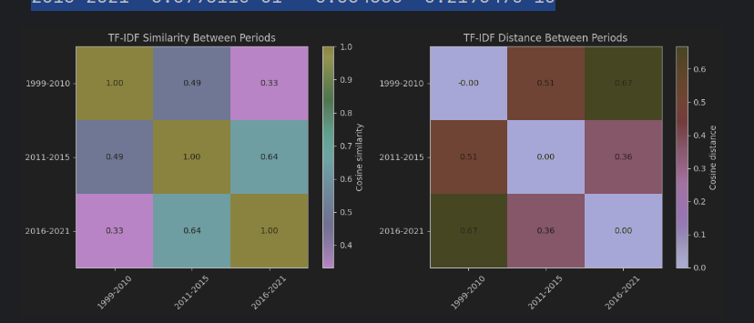
This result is very important because it gives an overall conclusion:

2011–2015 and 2016–2021 are the most similar.
1999–2010 and 2016–2021 are the least similar.
1999–2010 and 2011–2015 are at an intermediate level.

In other words, in terms of overall word usage, the three periods form a fairly clear evolutionary chain:
Early → Middle → Late, with the middle period acting more like a transition zone than a completely separate break.

LDA Section
1. Experimental Design

Within the overall comparative corpus analysis pipeline, LDA plays a different role from TF-IDF. TF-IDF is better at lexical comparison across time, whereas LDA is better suited to compressing abstracts from different periods into latent topic structures, so that we can observe how research focus shifts from one topic mixture to another. In other words, TF-IDF is more about seeing 'which words changed', while LDA is more about seeing 'how the underlying research topics associated with those words changed'.

This part of the experiment actually contains three layers of design.

The first layer is period-specific unigram LDA. Here, for each period, we built a separate dictionary and bag-of-words corpus, and then trained an LDA model independently. Because each period is modelled separately, this design is particularly suitable for qualitative interpretation: for example, whether the early period leans more toward kernel / bound / classifier, whether the middle period starts to show online / bandit / feature selection, and whether the later period clearly shifts toward neural / graph / reinforcement. The advantage is that each period’s topics are closely tied to its own corpus; the disadvantage is that topic IDs learned in different periods are not strictly comparable.

The second layer is period-specific bigram LDA. To make the topics move from collections of single words toward structures closer to method names or technical phrases, we introduced Phrases / Phraser to build bigram representations, bringing high-frequency phrases such as neural_network, feature_selection, and latent_variable directly into the LDA vocabulary. In this version, the number of topics was increased to 7 in the hope of capturing finer technical structure. The core purpose was to improve interpretability: compared with vague unigram terms such as network, feature, and classification, bigrams can be linked more directly to specific method families.

The third layer is global LDA. Because period-specific LDA models are easy to interpret separately but their topics cannot be aligned one-to-one across periods, we also trained a shared-topic-space LDA model on the full document set. Here we used tokens_bigram from all periods combined and trained a global model with 10 topics and passes=10. The purpose of this design was to provide a unified topic reference frame for the three periods. Each document can then be projected into the same set of global topics, after which we can average the topic distributions within each period and calculate cosine similarity / distance between periods. In this way, LDA can show not only 'what topics each period contains' but also 'how far apart different periods are in the same topic space'.

2. Comparative Results
2.1 Period-Specific Unigram LDA: An Initial View of Topic Evolution

Even in the most basic unigram LDA, fairly clear topic differences already appear across periods.

1999–2010
Topic 0: 0.021*"prediction" + 0.016*"loss" + 0.013*"class" + 0.013*"expert" + 0.011*"decision" + 0.010*"bound" + 0.010*"example" + 0.010*"information" + 0.008*"complexity" + 0.008*"classifier"
Topic 1: 0.021*"class" + 0.019*"measure" + 0.018*"distribution" + 0.015*"rule" + 0.015*"tree" + 0.014*"error" + 0.013*"language" + 0.012*"stochastic" + 0.012*"bayes" + 0.011*"probability"
Topic 2: 0.015*"accuracy" + 0.014*"technique" + 0.013*"mean" + 0.012*"strategy" + 0.011*"classification" + 0.011*"variable" + 0.011*"bound" + 0.011*"prior" + 0.011*"feature" + 0.010*"bayesian"
Topic 3: 0.016*"clustering" + 0.013*"convex" + 0.013*"distribution" + 0.012*"estimate" + 0.011*"group" + 0.011*"dimension" + 0.010*"optimization" + 0.009*"existing" + 0.009*"distance" + 0.008*"risk"
Topic 4: 0.025*"kernel" + 0.018*"log" + 0.016*"bound" + 0.015*"non" + 0.015*"matrix" + 0.013*"complex" + 0.013*"margin" + 0.013*"application" + 0.009*"machine" + 0.009*"svm"
The more prominent terms in the early-period topics include:
• prediction, loss, expert, decision, bound, classifier
• distribution, rule, tree, bayes, probability
• clustering, convex, estimate, optimization
• kernel, margin, machine, svm
• Overall, this stage is more strongly oriented toward:
• Classical classification and kernel methods
• Statistical learning and probabilistic modelling
• Theoretical analysis and bounds
• Rules, tree models, and early optimisation-related language
• 2011–2015
===== 2011-2015 =====
Topic 0: 0.013*"class" + 0.012*"loss" + 0.010*"online" + 0.010*"bound" + 0.009*"function" + 0.009*"optimization" + 0.008*"measure" + 0.008*"gradient" + 0.008*"classification" + 0.007*"stochastic"
Topic 1: 0.012*"network" + 0.010*"clustering" + 0.009*"graph" + 0.008*"space" + 0.007*"deep" + 0.007*"distance" + 0.007*"inference" + 0.006*"series" + 0.005*"structure" + 0.005*"representation"
Topic 2: 0.015*"regret" + 0.012*"distribution" + 0.012*"policy" + 0.011*"bound" + 0.010*"bandit" + 0.010*"reward" + 0.009*"arm" + 0.008*"optimal" + 0.007*"setting" + 0.007*"value"
Topic 3: 0.011*"label" + 0.011*"feature" + 0.011*"classifier" + 0.010*"training" + 0.009*"classification" + 0.008*"domain" + 0.008*"machine" + 0.007*"prediction" + 0.007*"supervised" + 0.007*"network"
Topic 4: 0.022*"feature" + 0.016*"kernel" + 0.011*"classification" + 0.009*"selection" + 0.008*"machine" + 0.007*"multi" + 0.007*"matrix" + 0.007*"optimization" + 0.007*"training" + 0.006*"accuracy"
The middle-period topics begin to look more mixed, with keywords including:
• online, bound, optimization, gradient, stochastic
• network, graph, deep, series, representation
• regret, policy, bandit, reward, arm
• feature, classifier, training, domain, supervised
• feature, kernel, selection, machine
• This suggests several important changes in the middle period:
• Traditional kernel / classification topics are still present
• But online learning, bandits, and gradient-based optimisation have become more visible
• Network, graph, and deep begin to enter the topic structure
• Middle-period features such as feature selection are also becoming stronger
• 2016–2021
===== 2016-2021 =====
Topic 0: 0.010*"training" + 0.008*"network" + 0.007*"deep" + 0.007*"machine" + 0.007*"federated" + 0.007*"client" + 0.006*"accuracy" + 0.006*"device" + 0.006*"detection" + 0.005*"anomaly"
Topic 1: 0.028*"network" + 0.020*"neural" + 0.014*"training" + 0.010*"deep" + 0.009*"parameter" + 0.009*"gradient" + 0.008*"optimization" + 0.007*"architecture" + 0.006*"layer" + 0.005*"search"
Topic 2: 0.017*"policy" + 0.010*"reinforcement" + 0.010*"adversarial" + 0.010*"bound" + 0.009*"agent" + 0.008*"reward" + 0.008*"domain" + 0.008*"setting" + 0.008*"sample" + 0.007*"environment"
Topic 3: 0.033*"graph" + 0.018*"network" + 0.016*"representation" + 0.015*"feature" + 0.012*"node" + 0.009*"information" + 0.009*"neural" + 0.008*"label" + 0.007*"structure" + 0.007*"classification"
Topic 4: 0.010*"machine" + 0.009*"prediction" + 0.009*"feature" + 0.007*"distribution" + 0.006*"datasets" + 0.006*"classification" + 0.005*"classifier" + 0.005*"decision" + 0.005*"training" + 0.005*"study"
The later-period topics shift more clearly toward modern machine learning:
• training, network, deep, federated, client, device
• network, neural, gradient, optimization, architecture, layer
• policy, reinforcement, agent, reward, environment
• graph, representation, node, neural, structure
• prediction, feature, datasets, classification
• The thematic centre of this period clearly falls on:
• deep / neural network
• graph representation / node-level learning
• reinforcement learning
• federated learning
• A more dataset-driven, training-oriented, and architecture-oriented style of research expression
• If we look only at this layer of results, LDA already supports a fairly clear narrative:
Research topics move from early kernel / Bayes / probability / classifier themes, to middle-period optimisation / feature selection / bandits, and then further toward later neural / graph / RL / federated learning themes.

2.2 Bigram LDA: Topics Become More Specific and More Interpretable

In the bigram version, topic interpretability improves substantially because the vocabulary starts to include technical phrases such as latent_variable, feature_selection, and neural_network.

• 1999–2010
===== 1999-2010 =====
Topic 0: 0.045*"prediction" + 0.030*"class" + 0.020*"strategy" + 0.013*"known" + 0.011*"continuous" + 0.011*"space" + 0.011*"matrix" + 0.010*"assumption" + 0.010*"regression" + 0.009*"measure"
Topic 1: 0.024*"expert" + 0.016*"bound" + 0.015*"label" + 0.015*"class" + 0.014*"mean" + 0.014*"distribution" + 0.014*"loss" + 0.013*"hybrid" + 0.012*"tree" + 0.011*"classifier"
Topic 2: 0.022*"dimension" + 0.021*"classifier" + 0.016*"bound" + 0.013*"estimator" + 0.013*"accuracy" + 0.012*"distribution" + 0.010*"parameter" + 0.010*"estimate" + 0.010*"set" + 0.009*"measure"
Topic 3: 0.020*"information" + 0.016*"setting" + 0.015*"latent_variable" + 0.014*"general" + 0.012*"label" + 0.011*"given" + 0.011*"condition" + 0.011*"active" + 0.010*"probabilistic" + 0.010*"prior"
Topic 4: 0.024*"solution" + 0.023*"example" + 0.019*"cluster" + 0.014*"probability" + 0.013*"control" + 0.011*"node" + 0.011*"power" + 0.011*"sample" + 0.010*"requirement" + 0.009*"information"
Topic 5: 0.024*"kernel" + 0.016*"bayes" + 0.015*"loss" + 0.014*"distribution" + 0.012*"complex" + 0.011*"input" + 0.010*"network" + 0.010*"machine" + 0.010*"information" + 0.010*"target"
Topic 6: 0.026*"optimization" + 0.021*"clustering" + 0.019*"rule" + 0.017*"feature" + 0.017*"technique" + 0.014*"classification" + 0.011*"bound" + 0.011*"sample" + 0.010*"attribute" + 0.010*"accuracy"
Typical expressions that appear in early-period bigram topics include:
• prediction
• expert
• bound
• latent_variable
• probabilistic
• kernel
• bayes
• clustering
• rule
• Compared with unigram LDA, the technical style of early research is more clearly visible here, and still leans toward:
• Prediction theory
• Probabilistic and Bayesian expressions
• latent variable / probabilistic modelling
• Kernel methods and traditional clustering
• 2011–2015
Topic 0: 0.013*"class" + 0.009*"classifier" + 0.009*"setting" + 0.009*"graph" + 0.008*"kernel" + 0.008*"matrix" + 0.007*"classification" + 0.006*"solution" + 0.006*"study" + 0.006*"optimization"
Topic 1: 0.016*"feature" + 0.013*"feature_selection" + 0.010*"arm" + 0.009*"sample" + 0.007*"distribution" + 0.005*"linear" + 0.005*"experiment" + 0.005*"function" + 0.004*"cost" + 0.004*"framework"
Topic 2: 0.013*"network" + 0.011*"online" + 0.011*"feature" + 0.008*"classification" + 0.008*"training" + 0.007*"deep" + 0.007*"technique" + 0.006*"framework" + 0.006*"analysis" + 0.004*"learn"
Topic 3: 0.011*"kernel" + 0.010*"label" + 0.009*"machine" + 0.008*"classification" + 0.006*"classifier" + 0.006*"training" + 0.006*"constraint" + 0.006*"svm" + 0.006*"optimization" + 0.005*"work"
Topic 4: 0.013*"policy" + 0.008*"training" + 0.007*"bound" + 0.007*"reinforcement" + 0.006*"process" + 0.006*"prediction" + 0.006*"reward" + 0.005*"feature" + 0.005*"exploration" + 0.005*"user"
Topic 5: 0.035*"clustering" + 0.012*"cluster" + 0.011*"mean" + 0.009*"representation" + 0.008*"user" + 0.007*"technique" + 0.006*"space" + 0.005*"ensemble" + 0.005*"type" + 0.005*"datasets"
Topic 6: 0.010*"measure" + 0.010*"classification" + 0.009*"metric" + 0.008*"framework" + 0.007*"optimization" + 0.007*"machine" + 0.006*"study" + 0.006*"classifier" + 0.006*"class" + 0.006*"feature"

The middle-period bigram topics contain more specific technical expressions:
• feature_selection
• network
• online
• policy
• reinforcement
• svm
• clustering
• kernel
• The transitional nature of this stage is even clearer in the bigram setting:
It retains svm and kernel on one side, while feature_selection, reinforcement, and network appear on the other, which is much closer to later research trends.

• 2016–2021
===== 2016-2021 =====
Topic 0: 0.020*"policy" + 0.013*"agent" + 0.011*"reward" + 0.010*"setting" + 0.010*"environment" + 0.009*"reinforcement" + 0.008*"online" + 0.007*"action" + 0.005*"study" + 0.005*"regret"
Topic 1: 0.023*"graph" + 0.012*"network" + 0.009*"feature" + 0.008*"representation" + 0.008*"training" + 0.008*"node" + 0.008*"label" + 0.006*"datasets" + 0.006*"framework" + 0.006*"deep"
Topic 2: 0.014*"machine" + 0.007*"training" + 0.007*"accuracy" + 0.006*"ensemble" + 0.006*"classifier" + 0.006*"federated" + 0.006*"technique" + 0.005*"classification" + 0.005*"client" + 0.005*"application"
Topic 3: 0.010*"dynamic" + 0.008*"solution" + 0.006*"prediction" + 0.006*"machine" + 0.006*"trajectory" + 0.005*"simulation" + 0.005*"system" + 0.004*"behavior" + 0.004*"control" + 0.004*"equation"
Topic 4: 0.024*"network" + 0.022*"training" + 0.015*"neural_network" + 0.009*"parameter" + 0.009*"deep" + 0.008*"optimization" + 0.008*"gradient" + 0.007*"architecture" + 0.007*"layer" + 0.006*"weight"
Topic 5: 0.008*"clustering" + 0.007*"matrix" + 0.007*"loss" + 0.006*"linear" + 0.006*"point" + 0.006*"sample" + 0.005*"distribution" + 0.005*"kernel" + 0.005*"class" + 0.005*"analysis"
Topic 6: 0.011*"prediction" + 0.008*"feature" + 0.007*"distribution" + 0.006*"information" + 0.006*"series" + 0.005*"representation" + 0.004*"patient" + 0.004*"domain" + 0.004*"machine" + 0.004*"framework"
The later-period bigram topics are more clearly reflected in:
• policy, agent, reward, reinforcement
• graph, node, representation
• federated, client
• neural_network, training, architecture, gradient
• series
This layer has a clear advantage over unigram LDA because it can directly support report-level descriptions of method families, rather than staying at the level of vague keywords.

2.3 Global LDA: Comparing Topic Distributions in a Shared Topic Space

To place different periods in the same topic space for comparison, we trained a global LDA model.
Topic 0: 0.016*"prediction" + 0.014*"machine" + 0.007*"study" + 0.007*"series" + 0.006*"deep" + 0.006*"feature" + 0.006*"patient" + 0.005*"pattern" + 0.005*"system" + 0.005*"technique"
Topic 1: 0.036*"network" + 0.030*"neural_network" + 0.022*"training" + 0.016*"layer" + 0.016*"deep" + 0.013*"weight" + 0.010*"deep_neural" + 0.010*"architecture" + 0.008*"loss" + 0.007*"input"
Topic 2: 0.016*"classifier" + 0.014*"classification" + 0.011*"accuracy" + 0.011*"metric" + 0.010*"training" + 0.010*"class" + 0.008*"measure" + 0.008*"machine" + 0.007*"cost" + 0.007*"decision_tree"
Topic 3: 0.016*"training" + 0.014*"label" + 0.011*"distribution" + 0.011*"sample" + 0.008*"framework" + 0.007*"domain" + 0.006*"datasets" + 0.006*"existing" + 0.005*"work" + 0.005*"example"
Topic 4: 0.019*"training" + 0.019*"federated" + 0.015*"client" + 0.015*"local" + 0.013*"device" + 0.012*"attack" + 0.012*"distributed" + 0.011*"network" + 0.008*"framework" + 0.008*"user"
Topic 5: 0.028*"feature" + 0.023*"clustering" + 0.016*"classification" + 0.014*"classifier" + 0.010*"ensemble" + 0.010*"cluster" + 0.009*"feature_selection" + 0.009*"selection" + 0.008*"user" + 0.008*"kernel"
Topic 6: 0.050*"graph" + 0.020*"representation" + 0.018*"node" + 0.013*"network" + 0.012*"information" + 0.011*"structure" + 0.010*"graph_neural" + 0.009*"feature" + 0.008*"gnns" + 0.007*"gnn"
Topic 7: 0.018*"optimization" + 0.013*"gradient" + 0.010*"solution" + 0.010*"training" + 0.007*"parameter" + 0.006*"matrix" + 0.006*"search" + 0.006*"meta" + 0.006*"design" + 0.005*"machine"
Topic 8: 0.019*"network" + 0.013*"dynamic" + 0.012*"agent" + 0.009*"environment" + 0.008*"architecture" + 0.008*"reinforcement" + 0.006*"policy" + 0.005*"forecasting" + 0.005*"learn" + 0.005*"representation"
Topic 9: 0.016*"policy" + 0.011*"setting" + 0.010*"bound" + 0.009*"reward" + 0.008*"online" + 0.007*"distribution" + 0.007*"study" + 0.006*"class" + 0.005*"consider" + 0.005*"regret"

Among the 10 global topics extracted by this model, the clearest directions include:
• Topic 1：network, neural_network, training, deep, layer, architecture
• → Deep learning / neural networks
• Topic 4：federated, client, local, device, distributed
• → Federated learning
• Topic 5：feature, clustering, classification, feature_selection, kernel
• → Traditional machine learning / clustering / feature selection
• Topic 6：graph, representation, node, graph_neural, gnn
• → Graph neural networks
• Topic 7：optimization, gradient, parameter, search, meta
• → Optimisation and parameter search
• Topic 8 / 9：agent, environment, policy, reward, regret, online
• → Reinforcement learning / online decision-making
The significance of this global model is that it places the early, middle, and later periods into the same topic reference framework. You then calculated the average topic distribution for each period and computed cosine similarity / distance.

The cosine similarity obtained is:

1999–2010 vs 2011–2015 = 0.963
1999–2010 vs 2016–2021 = 0.744
2011–2015 vs 2016–2021 = 0.864
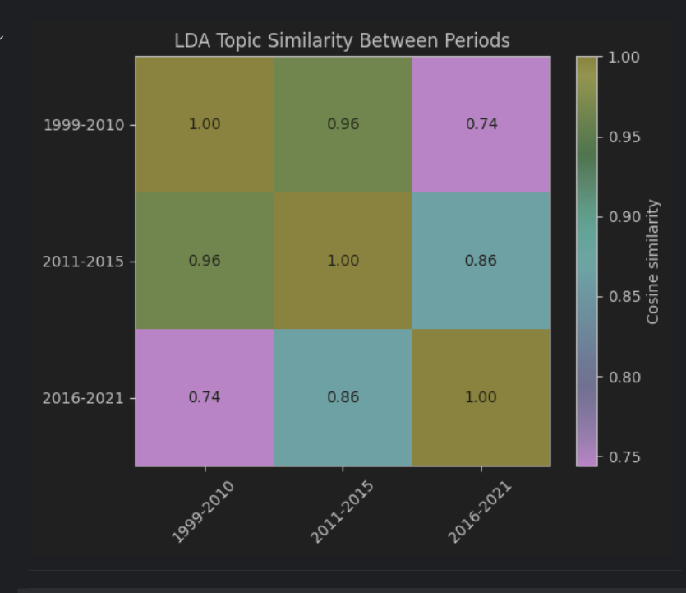
The corresponding cosine distance is:

1999–2010 vs 2011–2015 = 0.0368
1999–2010 vs 2016–2021 = 0.2559
2011–2015 vs 2016–2021 = 0.1364
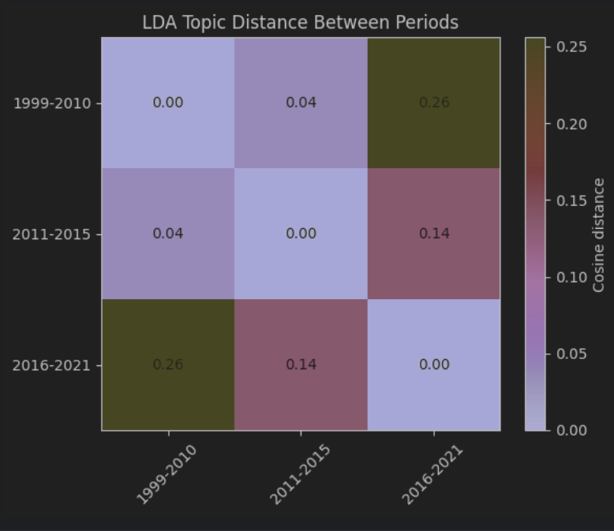
These results are fully consistent with the overall direction found by TF-IDF:
• The early and late periods are the least similar.
• The middle and late periods are closer to each other.
• The middle period is a transition stage.
The numerical differences in LDA are smaller than in TF-IDF, which suggests that LDA emphasises gradual change in topic structure rather than sharp breaks in surface vocabulary.

Topic-transition heatmap
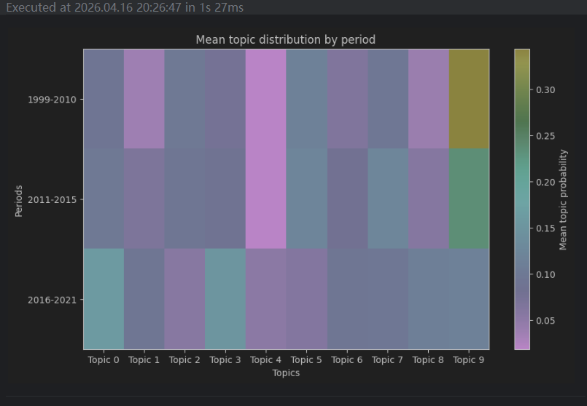

Overall, the LDA section does not provide the kind of very sharp lexical-drift picture that TF-IDF gives. Instead, it offers a smoother and more abstract path of topic evolution.

First, period-specific LDA clearly shows that research directions are shifting. The early period leans more toward classical machine-learning and statistical-learning language such as kernel, SVM, Bayes, probability, bound, and tree; the middle period begins to show transitional themes such as online learning, bandits, feature selection, gradient, and network; and by the later period, modern themes such as neural network, graph, reinforcement, and federated learning occupy a much more prominent position. This allows LDA to support a narrative about how research directions evolved, rather than simply which words became more common.

Second, the advantage of bigram LDA over unigram LDA is very clear. It transforms originally abstract topic words into expressions closer to real method names, such as feature_selection, neural_network, and latent_variable. Therefore, if the LDA results are to be written into the report, the bigram version is more suitable as display material because it is easier to read and easier to connect to the history of machine-learning research.

Third, the value of global LDA lies in providing a unified comparison scale. Because topic IDs in period-specific LDA cannot be aligned directly, the global model is what truly performs the cross-period comparison. Its cosine distance results are consistent with TF-IDF, again showing that 1999–2010 and 2016–2021 differ the most, with the middle period in between. This cross-method consistency is important because it suggests that temporal drift is not an accidental result produced by only one representation method, but something observable at both the lexical and topic-structure levels.

Fourth, Bryan’s follow-up experiments show that LDA does not just produce results; their quality is also strongly affected by preprocessing and parameter settings. After stricter stopword filtering, both coherence and distinctness increased, suggesting that if overly generic domain words are not removed, LDA can easily learn overlapping topics with weaker explanatory value. The parameter sweep further shows that the best number of topics is not fixed, but depends on the period, corpus size, and richness of the themes.

If we want to give an overall evaluation of LDA, we can say:
• It is not as sensitive as TF-IDF
• But it is better at summarising temporal change as topic-structure evolution
• With suitable preprocessing and parameter settings, its interpretability and robustness are both fairly strong
It is especially suitable as a middle layer between TF-IDF and BERTopic: it retains interpretability while also enabling structured comparison
4. Comparing Expectations with Actual Results
Expectation 1: LDA would be smoother than TF-IDF, but would still reflect temporal drift
This expectation is supported.
LDA’s cosine distance is clearly smaller than TF-IDF’s. For example, the greatest early–late difference is 0.256 in LDA, versus 0.667 in TF-IDF. This suggests that LDA compresses surface lexical differences into a more abstract topic space, making the change look smoother. But the direction itself does not change: the early and late periods are still the least similar, with the middle period acting as a transition.
Expectation 2: Bigrams would improve topic interpretability

This expectation is also supported.
Compared with unigram terms such as network, feature, and classification, bigram expressions such as feature_selection, neural_network, latent_variable, and svm are clearly more suitable for explanation and writing. So from the perspective of report communication, the value of bigram LDA is not simply that it performs better, but that it is easier for readers to understand.

Expectation 3: The middle period should be a transition from traditional methods to modern methods
This expectation is also supported.
The topics in 2011–2015 contain kernel, svm, and classification, but also gradient, online, policy, bandit, network, and feature_selection. This shows that the middle period is not just a vague blur, but a recognisable transitional stage.

Expectation 4: Stricter preprocessing should make topics clearer
This expectation is clearly supported by Bryan’s metric comparison.
Across all three periods, strict stopwords increased coherence and distinctness. This suggests that removing overly generic background words from the domain really does sharpen topic boundaries. This is a strength in the methods / evaluation write-up, because it shows that the models were not run mechanically, but were consciously tuned to improve topic quality.

Expectation 5: With a larger corpus, later-period topics should be more mature and clearer
This expectation is broadly supported.
2016–2021 not only has the highest coherence, but both global and period-specific LDA can also extract themes such as neural, graph, RL, and federated learning relatively stably. At the same time, however, caution is needed: because the later corpus is by far the largest, greater topic clarity may reflect not only real maturation in the research structure, but also the advantage of a larger sample size.

BERTopic Experimental Design
1. Experiment 1: Train a Unified BERTopic Model on the Full Corpus
Purpose of this experiment
This experiment does not split the corpus by period. Instead, it first learns a unified topic space over the entire corpus.
This then allows us to:
• See which topics are learned globally
• Assign each abstract to a topic
• Then count topic distributions by period
• Compare the three periods within the same topic coordinate system
2. Experiment 2: Inspect the Topics Learned by the Global BERTopic Model
===== Topic -1 =====
[('data', 0.02013006735194927), ('learning', 0.01862445899977339), ('model', 0.01315744382335799), ('based', 0.012125151605771826), ('models', 0.01154913899867994), ('paper', 0.010754087085978742), ('methods', 0.010644159964015345), ('algorithm', 0.01050571454281007), ('performance', 0.010427937075779548), ('method', 0.010322340468564352)]

===== Topic 0 =====
[('neural', 0.026834133284567453), ('networks', 0.026307367563402354), ('training', 0.02089269661755212), ('deep', 0.020693212252267085), ('network', 0.020182512730353458), ('neural networks', 0.019650531745845867), ('gradient', 0.01634638996848715), ('learning', 0.015029920833437817), ('deep learning', 0.011662104140382776), ('performance', 0.011491079861314661)]

===== Topic 1 =====
[('policy', 0.04054462288691043), ('reinforcement', 0.03418146779344446), ('reinforcement learning', 0.034074729394076485), ('rl', 0.0331557430376454), ('learning', 0.028850626149908448), ('agent', 0.021251124122485445), ('state', 0.017879691334069713), ('reward', 0.017167862395765298), ('policies', 0.016726819003038376), ('control', 0.01587692952009688)]

===== Topic 2 =====
[('graph', 0.07123726375328779), ('graphs', 0.03138015022690147), ('node', 0.030962917691312437), ('gnns', 0.022891453165941676), ('nodes', 0.019168652183952726), ('gnn', 0.018616909857572285), ('networks', 0.01853797020784024), ('graph neural', 0.017974947448690482), ('learning', 0.01500411712718541), ('neural', 0.014892247430390313)]

===== Topic 3 =====
[('patients', 0.02908683707396789), ('data', 0.02584540297970471), ('disease', 0.024555334356310535), ('clinical', 0.022811900725251556), ('patient', 0.022416880625954337), ('health', 0.021146074479320147), ('medical', 0.01922024109093657), ('model', 0.01861305033769892), ('prediction', 0.01690627791000903), ('cancer', 0.016624725897986078)]

===== Topic 4 =====
[('regret', 0.060689261037169415), ('bandit', 0.056087589169884294), ('arms', 0.034694544529949106), ('arm', 0.03368820924139615), ('reward', 0.03121533965900081), ('problem', 0.029962311139588513), ('algorithm', 0.02963327781735678), ('bandits', 0.029565334996063047), ('armed', 0.02639609069739965), ('multi armed', 0.023997734899320205)]

===== Topic 5 =====
[('generative', 0.04022533258729913), ('gan', 0.03396701296126646), ('gans', 0.02840124646011351), ('latent', 0.024917135541922097), ('data', 0.024767138997033093), ('distribution', 0.022489856485438383), ('models', 0.02042977967444476), ('variational', 0.018401543785235067), ('adversarial', 0.017906604141099493), ('model', 0.01776997090212266)]

===== Topic 6 =====
[('federated', 0.058254140968458976), ('privacy', 0.046840772394514056), ('federated learning', 0.04497777960333464), ('fl', 0.043134502288241776), ('clients', 0.03925048665676011), ('learning', 0.032336723009296305), ('data', 0.03169809785337599), ('communication', 0.024460654958049804), ('model', 0.02407806261279638), ('local', 0.023712992995949297)]

===== Topic 7 =====
[('adversarial', 0.08972741913583966), ('attacks', 0.04906156413156839), ('robustness', 0.04676757880314434), ('adversarial examples', 0.032856887775817606), ('examples', 0.029883633539879582), ('attack', 0.028844237266684874), ('training', 0.026440254457246126), ('adversarial training', 0.024702971219543315), ('adversarial attacks', 0.023468209891273704), ('neural', 0.020775100003438973)]

===== Topic 8 =====
[('traffic', 0.06618706231692424), ('spatial', 0.03674672615463875), ('temporal', 0.03485238261807798), ('data', 0.02376677177272951), ('prediction', 0.023251247892521976), ('time', 0.019798904301272006), ('road', 0.018390337187753424), ('network', 0.018118961851216316), ('graph', 0.01745232338237318), ('transportation', 0.01728593818203156)]
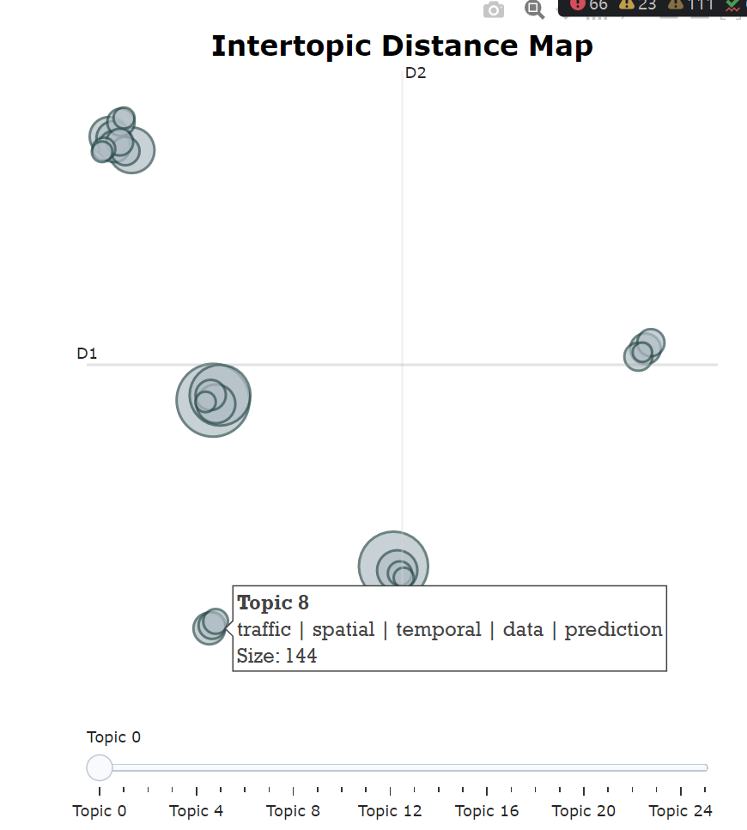
3. Experiment 3: Count the Topic Distribution of the Global BERTopic Model by Period

A table was constructed:
• Rows: the three periods
• 1999-2010
• 2011-2015
• 2016-2021
• Columns: each topic ID
• Values: the proportion of each topic within that period
• What this is intended to show:
• Within the same global topic space
• Which topics each period leans toward
• Whether the topic composition changes
bertopic_topic -1 0 1 2 3 4 \
period
1999-2010 0.524590 0.032787 0.061475 0.016393 0.008197 0.032787
2011-2015 0.411479 0.075875 0.057393 0.032101 0.019455 0.053502
2016-2021 0.280341 0.117360 0.106565 0.085844 0.048407 0.029601

bertopic_topic 5 6 7 8 ... 16 \
period ...
1999-2010 0.008197 0.000000 0.000000 0.004098 ... 0.000000
2011-2015 0.021401 0.007782 0.001946 0.006809 ... 0.007782
2016-2021 0.033780 0.036218 0.028731 0.023681 ... 0.016716

bertopic_topic 17 18 19 20 21 22 \
period
1999-2010 0.004098 0.012295 0.040984 0.008197 0.020492 0.000000
2011-2015 0.004864 0.016537 0.029183 0.002918 0.010700 0.002918
2016-2021 0.016890 0.011841 0.007487 0.012015 0.008184 0.010099

bertopic_topic 23 24 25
period
1999-2010 0.000000 0.065574 0.032787
2011-2015 0.006809 0.023346 0.029183
2016-2021 0.009229 0.003134 0.002786
4. Experiment 4: Compare the Three Periods Using Cosine Similarity / Distance
Treat the topic distribution of each period as a vector, and then calculate:
• cosine similarity
• cosine distance
Purpose of this experiment
This step is not about a single topic, but about:
• How similar the overall topic structures of the three periods are
• Which two periods are closer
• Which two periods differ more
• This is essentially a BERTopic version of period-distance comparison.
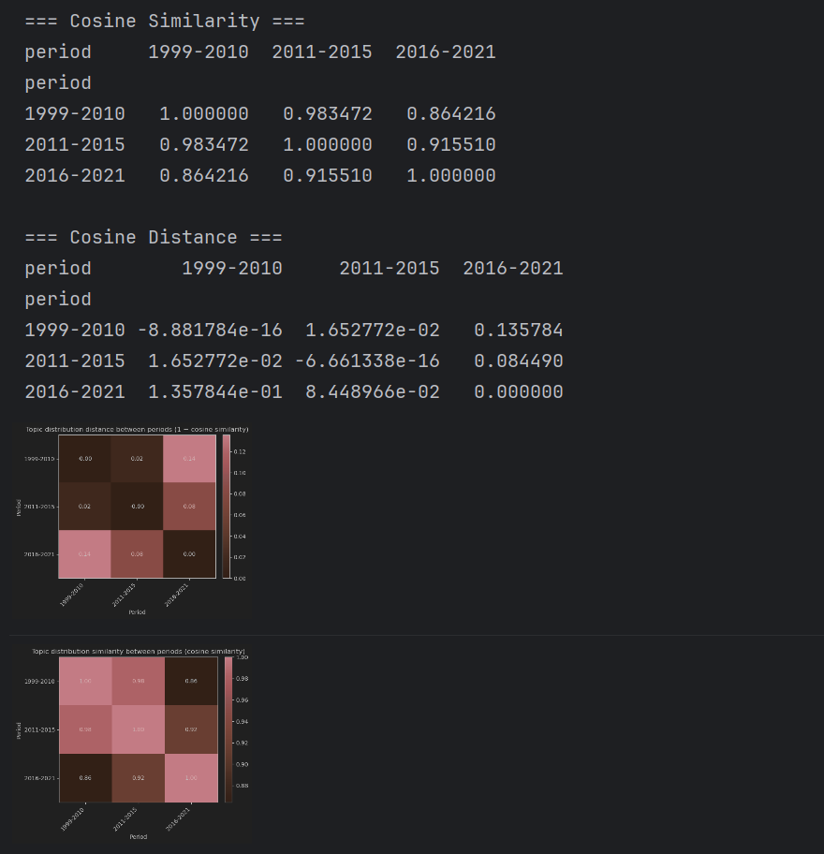
Experiment 5
1: Use a heatmap to show the proportion of each BERTopic topic across different time periods. Its purpose is to first observe the overall picture: which topics are more prominent in certain periods, and which topics may have changed over time.
2: On this basis, carry out a second layer of analysis. It first calculates the topic distribution in each period, excludes BERTopic’s outlier topic -1, identifies the top three topics in each period, and outputs their keywords so that the main content of each period can be judged more easily. Finally, it selects the six most common topics in the whole dataset and uses a stacked bar chart to compare how these major topics are composed across periods.
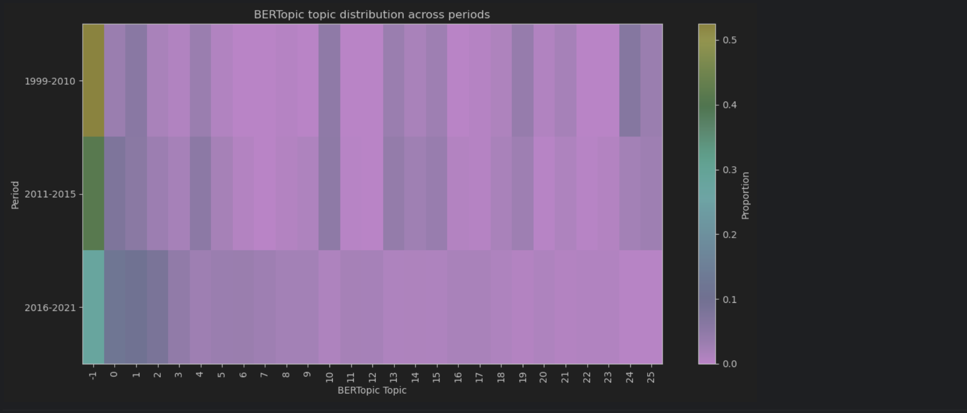

=== Top Topics Per Period (No Outliers) ===

===== 1999-2010 =====

Topic 24 | proportion = 0.066
[('class', 0.03836264684797867), ('complexity', 0.037736864480049204), ('vc', 0.03607197049055833), ('dimension', 0.03325722756731994), ('bounds', 0.0323744036000505), ('learning', 0.03204720307981447), ('sample', 0.03164711271440505), ('sample complexity', 0.02924832565731322), ('pac', 0.029054244478138355), ('vc dimension', 0.02885463129781969)]

Topic 1 | proportion = 0.061
[('policy', 0.04054462288691043), ('reinforcement', 0.03418146779344446), ('reinforcement learning', 0.034074729394076485), ('rl', 0.0331557430376454), ('learning', 0.028850626149908448), ('agent', 0.021251124122485445), ('state', 0.017879691334069713), ('reward', 0.017167862395765298), ('policies', 0.016726819003038376), ('control', 0.01587692952009688)]

Topic 10 | proportion = 0.049
[('matrix', 0.04853360968570241), ('kernel', 0.03657533091301024), ('rank', 0.022323205599685376), ('factorization', 0.020674985727082276), ('data', 0.01948371607344318), ('algorithm', 0.018106959471136403), ('problem', 0.01603457640833563), ('method', 0.015919515718425405), ('matrix factorization', 0.015710797956876296), ('metric', 0.015186628239789987)]

===== 2011-2015 =====

Topic 0 | proportion = 0.076
[('neural', 0.026834133284567453), ('networks', 0.026307367563402354), ('training', 0.02089269661755212), ('deep', 0.020693212252267085), ('network', 0.020182512730353458), ('neural networks', 0.019650531745845867), ('gradient', 0.01634638996848715), ('learning', 0.015029920833437817), ('deep learning', 0.011662104140382776), ('performance', 0.011491079861314661)]

Topic 1 | proportion = 0.057
[('policy', 0.04054462288691043), ('reinforcement', 0.03418146779344446), ('reinforcement learning', 0.034074729394076485), ('rl', 0.0331557430376454), ('learning', 0.028850626149908448), ('agent', 0.021251124122485445), ('state', 0.017879691334069713), ('reward', 0.017167862395765298), ('policies', 0.016726819003038376), ('control', 0.01587692952009688)]

Topic 4 | proportion = 0.054
[('regret', 0.060689261037169415), ('bandit', 0.056087589169884294), ('arms', 0.034694544529949106), ('arm', 0.03368820924139615), ('reward', 0.03121533965900081), ('problem', 0.029962311139588513), ('algorithm', 0.02963327781735678), ('bandits', 0.029565334996063047), ('armed', 0.02639609069739965), ('multi armed', 0.023997734899320205)]

===== 2016-2021 =====

Topic 0 | proportion = 0.117
[('neural', 0.026834133284567453), ('networks', 0.026307367563402354), ('training', 0.02089269661755212), ('deep', 0.020693212252267085), ('network', 0.020182512730353458), ('neural networks', 0.019650531745845867), ('gradient', 0.01634638996848715), ('learning', 0.015029920833437817), ('deep learning', 0.011662104140382776), ('performance', 0.011491079861314661)]

Topic 1 | proportion = 0.107
[('policy', 0.04054462288691043), ('reinforcement', 0.03418146779344446), ('reinforcement learning', 0.034074729394076485), ('rl', 0.0331557430376454), ('learning', 0.028850626149908448), ('agent', 0.021251124122485445), ('state', 0.017879691334069713), ('reward', 0.017167862395765298), ('policies', 0.016726819003038376), ('control', 0.01587692952009688)]

Topic 2 | proportion = 0.086
[('graph', 0.07123726375328779), ('graphs', 0.03138015022690147), ('node', 0.030962917691312437), ('gnns', 0.022891453165941676), ('nodes', 0.019168652183952726), ('gnn', 0.018616909857572285), ('networks', 0.01853797020784024), ('graph neural', 0.017974947448690482), ('learning', 0.01500411712718541), ('neural', 0.014892247430390313)]

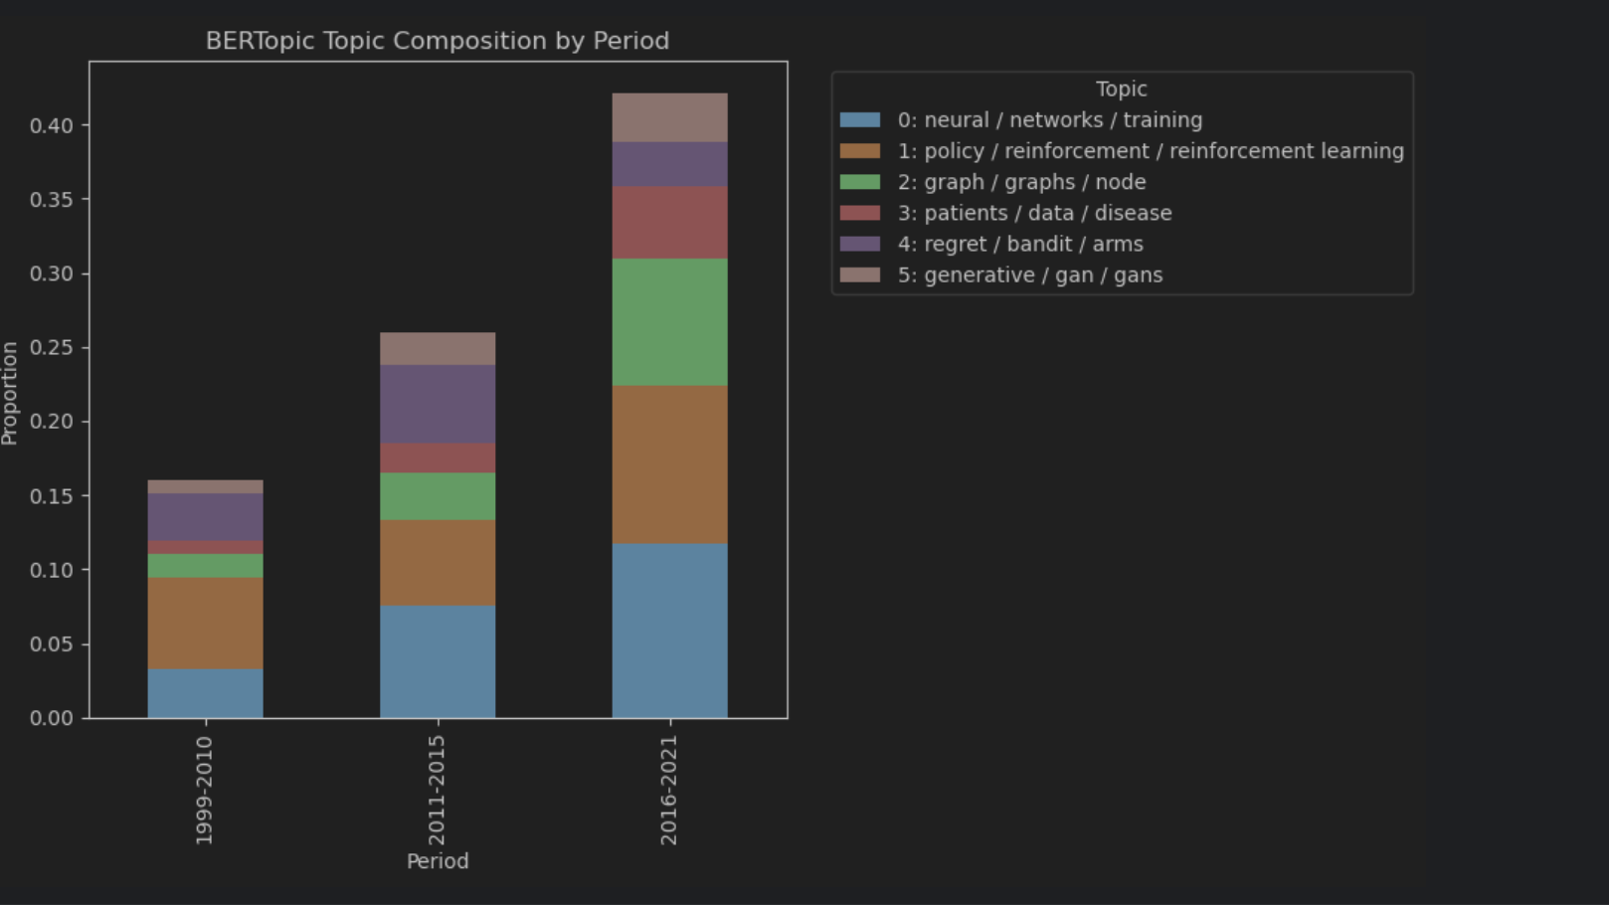

Experiment 6: Calculate the frequency of different topics in each year, and use a topic-evolution plot to observe whether major topics increase, decrease, or fluctuate over time. This uses the original year information directly, allowing BERTopic to analyse topic change against timestamps.
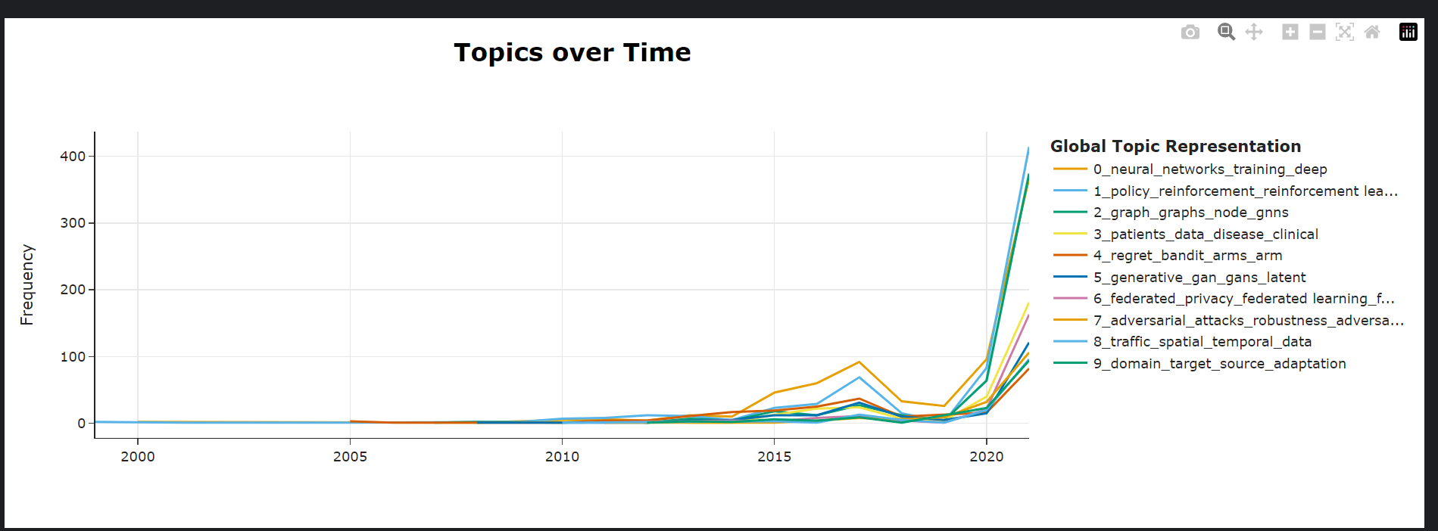
Experiment 7: Train BERTopic Separately for the Three Periods and Output the Results
After completing global BERTopic, group the data by period
Train a separate BERTopic model for each period
Still use an embedding model + vectorizer
Here, min_topic_size is set to 30
Specifically for:
• 1999–2010
• 2011–2015
• 2016–2021
• Train one model for each period.
Purpose of this experiment
What happens if we do not force everything into a single shared global topic space, but instead allow each period to generate its own topics?
This forms a contrast with global BERTopic:
• Global BERTopic: convenient for direct cross-period comparison
• Period-specific BERTopic: more suitable for looking at the internal topic structure of each period
The number of BERTopic topics is generated automatically. Because the early-period literature is smaller in size, the early period also produces fewer topics.

===== 1999-2010 =====
Topic Count Name \
0 -1 79 -1_learning_problem_algorithms_algorithm
1 0 91 0_data_learning_classification_algorithm
2 1 43 1_algorithm_prediction_regret_function
3 2 31 2_learning_log_complexity_distribution

Representation
0 [learning, problem, algorithms, algorithm, paper, data, class, method, using, complex]
1 [data, learning, classification, algorithm, model, paper, results, method, classifier, matrix]
2 [algorithm, prediction, regret, function, learning, experts, forecasting, problem, bound, expert]
3 [learning, log, complexity, distribution, sample, function, statistical, error, log log, generalization]

===== 2011-2015 =====
Topic Count Name \
0 -1 458 -1_learning_data_algorithm_based
1 0 126 0_deep_learning_networks_model
2 1 111 1_classification_cost_data_learning
3 2 96 2_regret_algorithm_online_bandit
4 3 66 3_learning_optimization_stochastic_algorithm
5 4 51 4_policy_learning_reinforcement_reinforcement learning
6 5 49 5_metric_kernel_matrix_learning
7 6 39 6_clustering_data_algorithm_clusters
8 7 32 7_time_time series_series_data

Representation
0 [learning, data, algorithm, based, model, paper, algorithms, methods, method, problem]
1 [deep, learning, networks, model, training, network, neural, models, data, gradient]
2 [classification, cost, data, learning, classifier, algorithm, problem, classifiers, svm, feature]
3 [regret, algorithm, online, bandit, problem, reward, arms, algorithms, optimal, arm]
4 [learning, optimization, stochastic, algorithm, loss, function, algorithms, complexity, descent, bounds]
5 [policy, learning, reinforcement, reinforcement learning, td, state, algorithm, markov, lambda, behavior]
6 [metric, kernel, matrix, learning, metric learning, method, distance, similarity, model, methods]
7 [clustering, data, algorithm, clusters, means, cluster, algorithms, points, set, clustering algorithm]
8 [time, time series, series, data, energy, shapelets, patterns, accuracy, weather, based]

===== 2016-2021 =====
Topic Count Name \
0 -1 1461 -1_data_learning_models_model
1 0 576 0_policy_rl_reinforcement_reinforcement learning
2 1 494 1_graph_graphs_node_gnns
3 2 381 2_networks_neural_neural networks_gradient
4 3 316 3_data_patients_disease_clinical
5 4 247 4_clustering_data_matrix_algorithm
6 5 221 5_federated_privacy_federated learning_fl
7 6 171 6_regret_bandit_algorithm_problem
8 7 163 7_adversarial_attacks_robustness_adversarial examples
9 8 141 8_label_labels_noisy_noise

Representation
0 [data, learning, models, model, based, neural, training, machine, performance, deep]
1 [policy, rl, reinforcement, reinforcement learning, learning, agent, reward, state, policies, control]
2 [graph, graphs, node, gnns, networks, nodes, learning, graph neural, gnn, neural]
3 [networks, neural, neural networks, gradient, deep, training, network, learning, descent, function]
4 [data, patients, disease, clinical, model, patient, health, using, medical, prediction]
5 [clustering, data, matrix, algorithm, view, kernel, method, multi view, means, proposed]
6 [federated, privacy, federated learning, fl, clients, learning, data, communication, model, local]
7 [regret, bandit, algorithm, problem, arm, arms, reward, bandits, armed, setting]
8 [adversarial, attacks, robustness, adversarial examples, examples, attack, training, adversarial training, adversarial attacks, robust]
9 [label, labels, noisy, noise, data, multi label, learning, label noise, classification, training]

Experiment 8
After completing both global BERTopic and period-specific BERTopic, I designed a unified run_bertopic_experiment() function to test different BERTopic settings under the same workflow. This function can control four factors—embedding model, whether to use KMeans, whether to apply outlier reduction, min_topic_size, and n_clusters—so that different experiments remain comparable. Based on this unified framework, I ran four BERTopic variants: a baseline using all-MiniLM-L6-v2 with default HDBSCAN, a version with reduce_outliers added, a version that replaced HDBSCAN clustering with KMeans, and a version that replaced the embedding model with all-mpnet-base-v2. I then analysed these four versions in a unified way, including comparison of outlier ratio, inspection of top topics in each period, generation of heatmaps, stacked bar charts, and topic-evolution plots, and finally comparison of outlier proportions across methods in a summary table. The purpose of this experiment is not simply to generate topics, but to test the stability of BERTopic under different parameter and model settings, to observe whether different configurations significantly change topic structure, the proportion of outlier texts, and period-comparison results, and thereby to judge which BERTopic setup is most suitable for the current topic-evolution analysis task.

Baseline:
• embedding: all-MiniLM-L6-v2
• Default HDBSCAN
• No outlier reduction

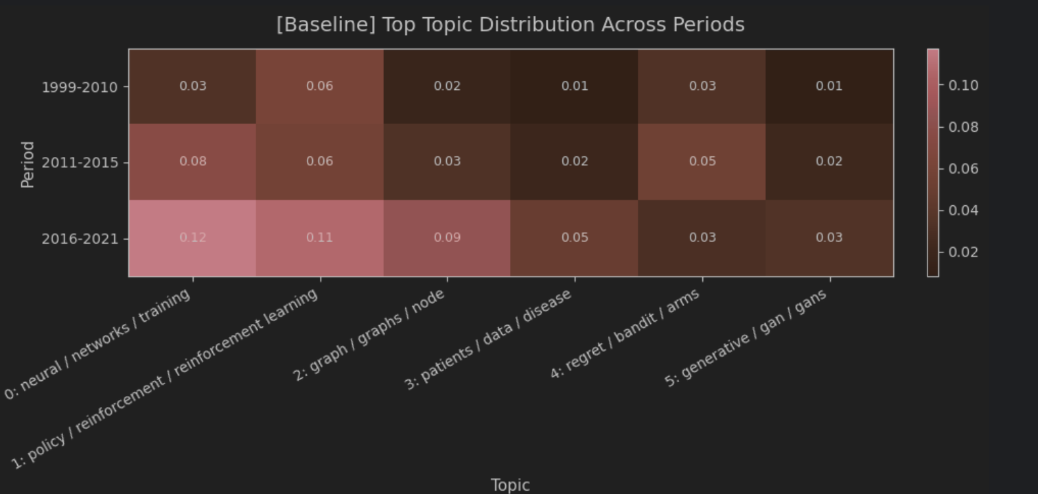
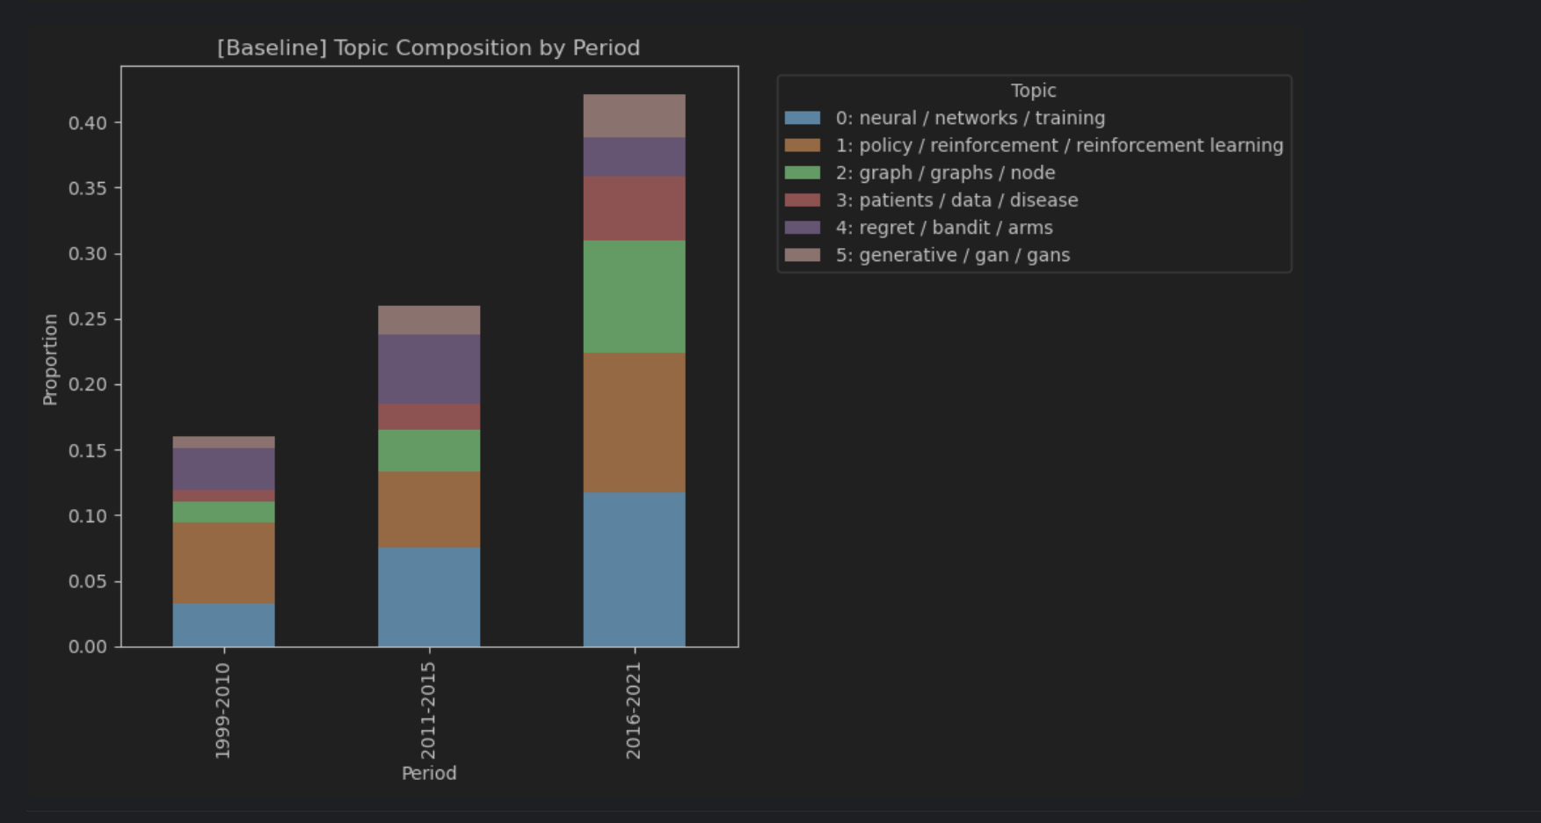

10.2 Reduce Outliers
• embedding: all-MiniLM-L6-v2
• Default HDBSCAN
• Apply reduce_outliers after training
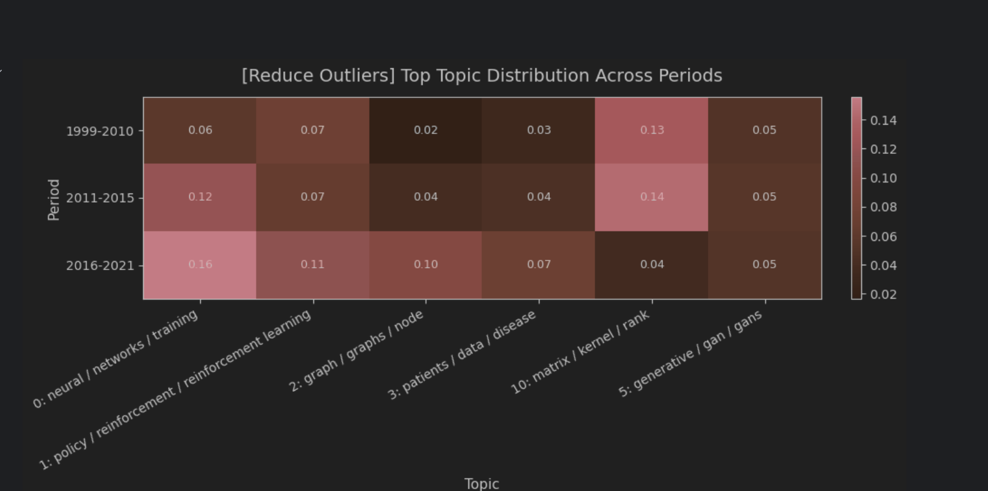
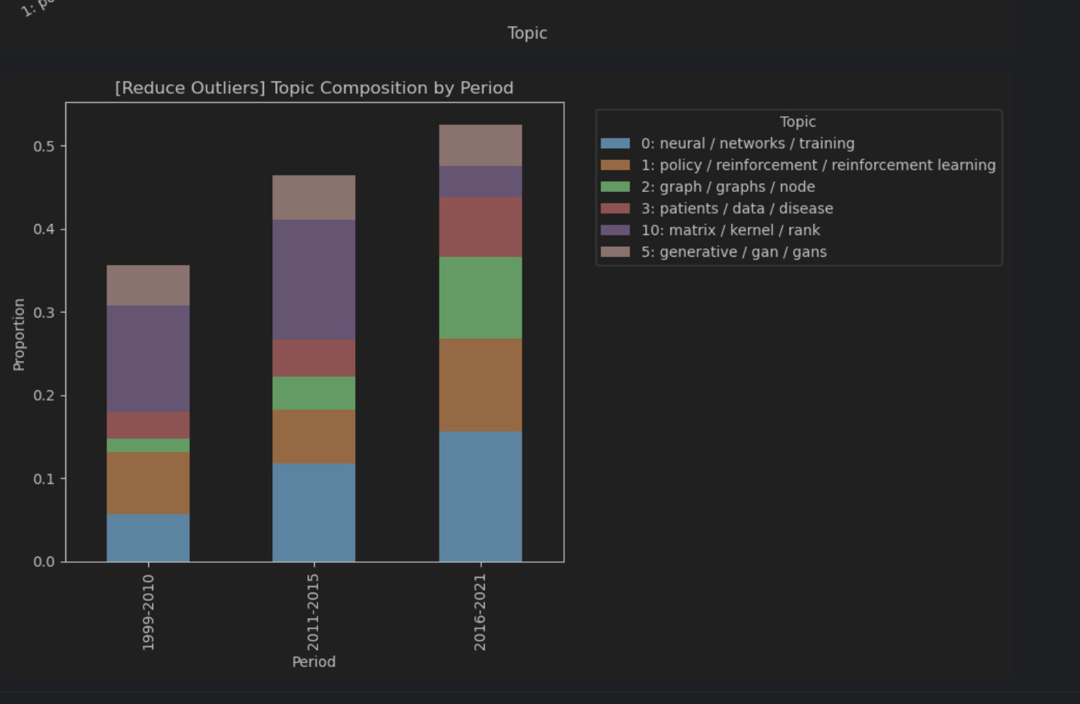
10.3 KMeans
• embedding: all-MiniLM-L6-v2
• Replace clustering with KMeans
Do not use the HDBSCAN outlier mechanism
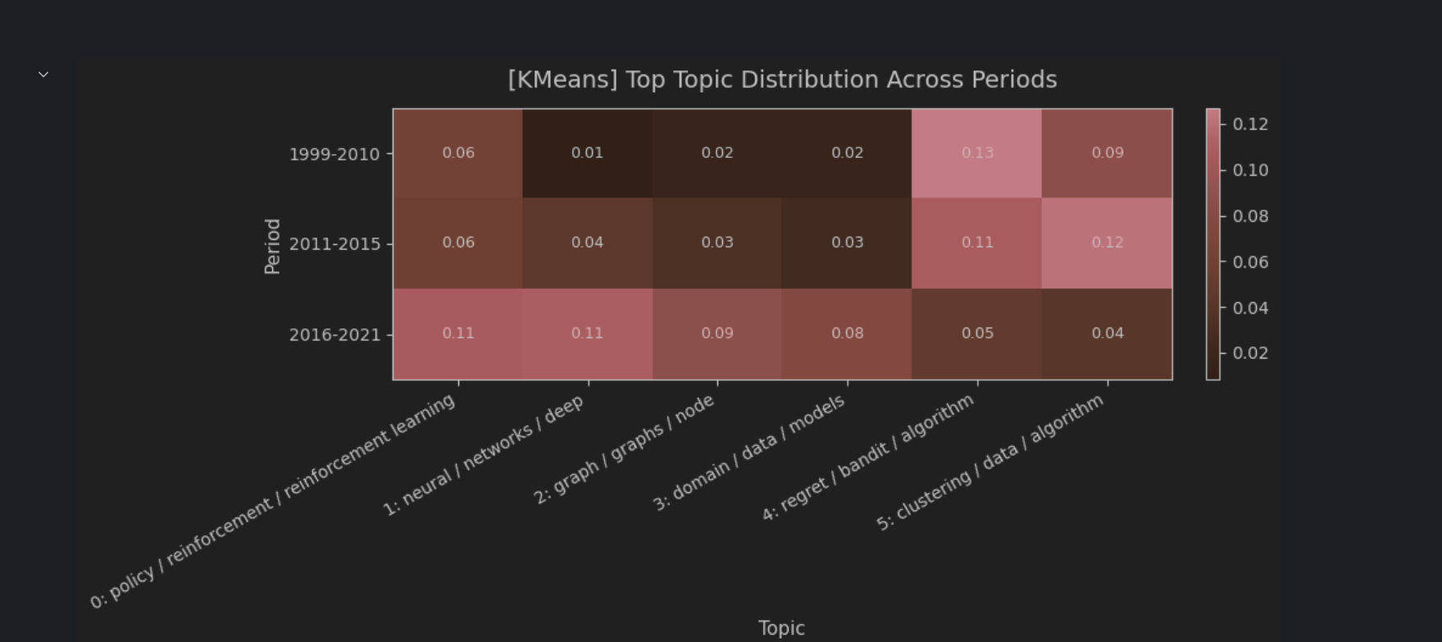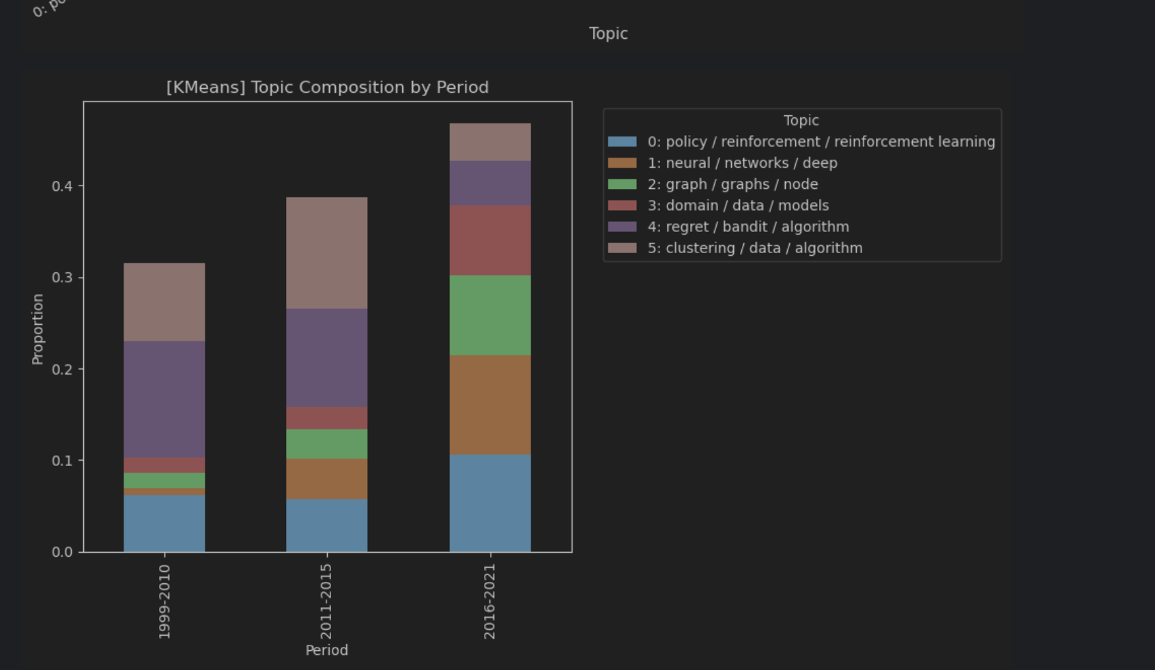

10.4 MPNet
Replace the embedding model with all-mpnet-base-v2
Keep the rest of the workflow basically the same as the baseline
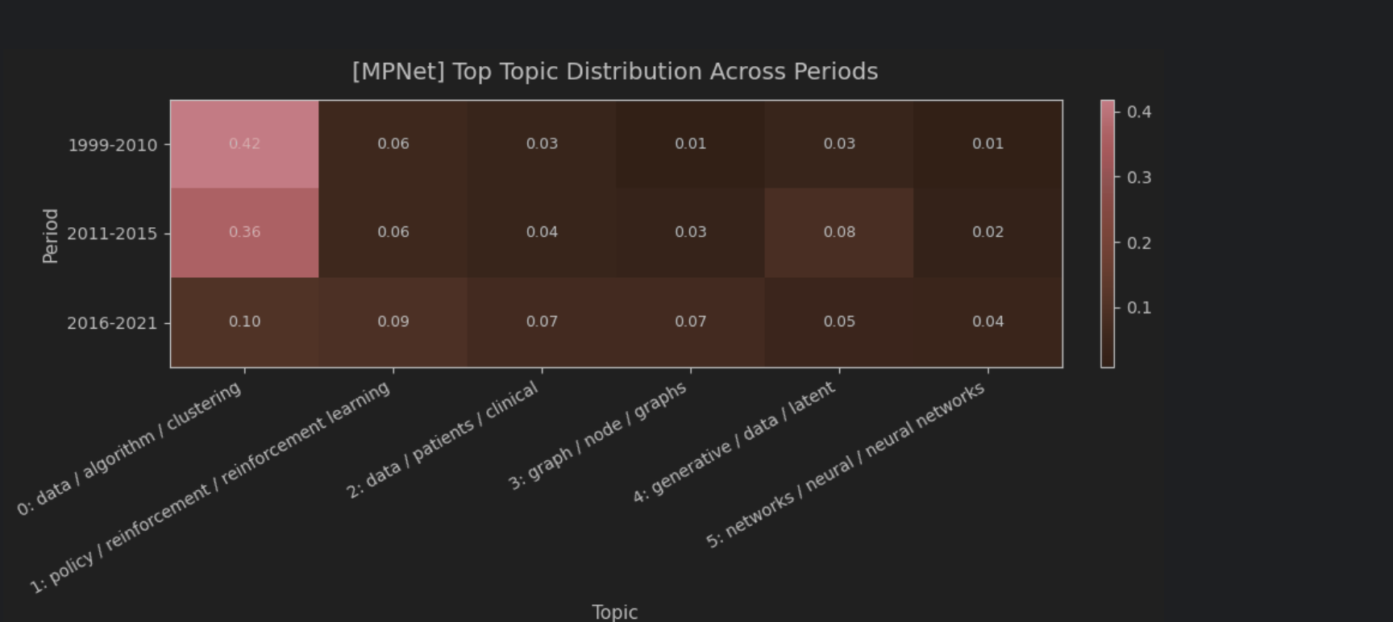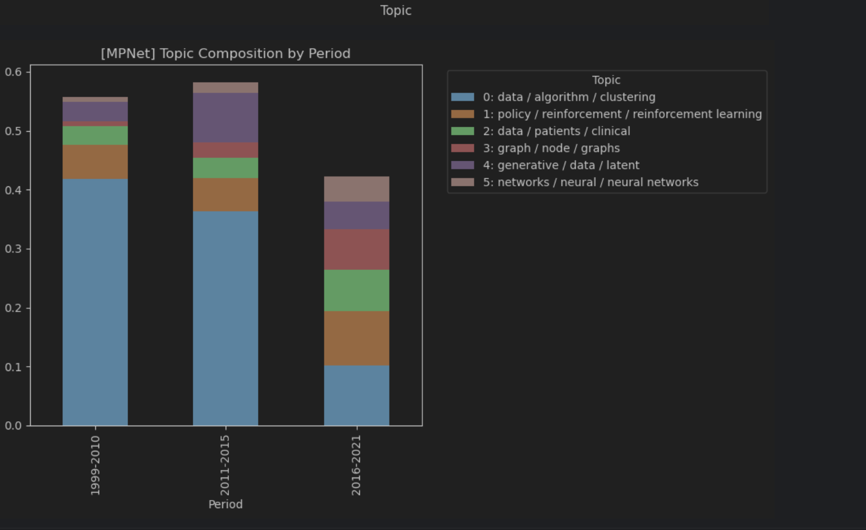

Outlier comparison
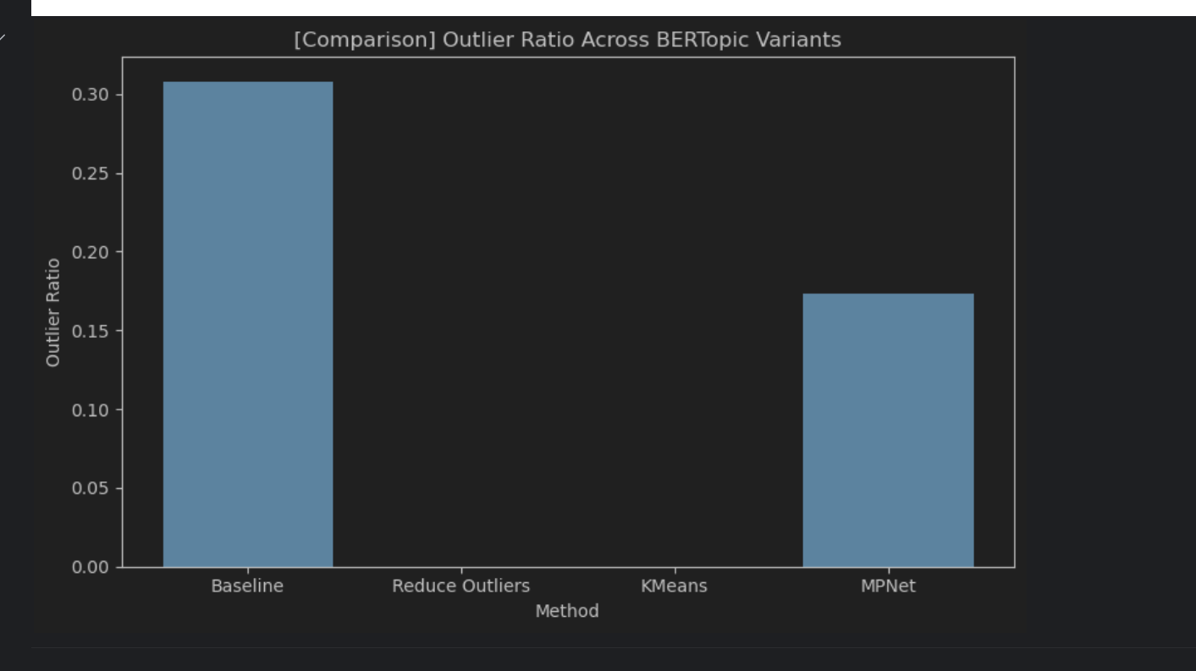

HDP Experiments
I added HDP not because it is necessarily better than LDA, but because it can serve as a supplementary topic-model comparison method. LDA requires the number of topics to be fixed in advance, whereas HDP can learn topic structure automatically within a probabilistic framework. This allows us to judge whether the temporal changes observed under LDA are affected by the chosen number of topics.
In addition, although HDP and BERTopic both avoid manually fixing the number of topics, they work through different mechanisms: HDP is still a traditional probabilistic topic model, while BERTopic is an embedding + clustering semantic topic model. So by adding HDP, we can form a more complete comparison among topic-based methods: LDA with a fixed number of topics, HDP with automatically learned topic structure, and BERTopic with semantic clustering.
In terms of design, I split HDP into two lines as well: modelling on the full corpus and modelling by period. The former is for comparing the three periods within a shared topic space, while the latter is for observing the internal topic structure of each period. The expectation is that this allows us to see both overall temporal differences and whether different periods form different internal topic organisations.

Experiment 1:
Full-corpus HDP first builds a shared topic space over the entire corpus
Then extracts the topic distribution of each document
Then aggregates by period
Finally compares the overall topic differences among the three periods

== Sample HDP Topics ===

===== Topic 0 =====
0.012*network + 0.007*neural + 0.007*graph + 0.007*training + 0.006*feature + 0.006*deep + 0.005*prediction + 0.004*work + 0.004*machine + 0.004*classification

===== Topic 1 =====
0.010*network + 0.007*training + 0.006*neural + 0.005*deep + 0.004*feature + 0.004*work + 0.004*prediction + 0.004*distribution + 0.004*policy + 0.004*framework

===== Topic 2 =====
0.006*network + 0.005*feature + 0.005*training + 0.004*machine + 0.004*policy + 0.004*neural + 0.004*distribution + 0.004*bound + 0.003*deep + 0.003*sample

===== Topic 3 =====
0.007*network + 0.006*feature + 0.004*neural + 0.003*training + 0.003*deep + 0.003*graph + 0.003*work + 0.003*prediction + 0.003*information + 0.003*multi

===== Topic 4 =====
0.004*network + 0.003*feature + 0.003*prediction + 0.002*classification + 0.002*kernel + 0.002*training + 0.002*graph + 0.002*deep + 0.002*class + 0.002*machine

===== Topic 5 =====
0.004*network + 0.004*feature + 0.003*training + 0.002*machine + 0.002*graph + 0.002*neural + 0.002*information + 0.002*deep + 0.002*study + 0.002*classification

===== Topic 6 =====
0.003*network + 0.002*training + 0.002*machine + 0.002*classification + 0.002*feature + 0.002*cost + 0.002*neural + 0.002*label + 0.002*policy + 0.002*framework

===== Topic 7 =====
0.002*setting + 0.002*instance + 0.002*parameter + 0.002*space + 0.002*value + 0.001*classifier + 0.001*online + 0.001*random + 0.001*cost + 0.001*accuracy

===== Topic 8 =====
0.003*matrix + 0.002*feature + 0.002*bound + 0.002*target + 0.002*training + 0.002*blending + 0.002*online + 0.001*rate + 0.001*order + 0.001*multi

===== Topic 9 =====
0.002*network + 0.002*clustering + 0.002*hawkes + 0.001*graph + 0.001*work + 0.001*convergence + 0.001*classification + 0.001*technique + 0.001*mean + 0.001*class

Number of used HDP topics: 146
First 30 topic ids: [0, 1, 2, 3, 4, 5, 6, 7, 8, 9, 10, 11, 12, 13, 14, 15, 16, 17, 18, 19, 20, 21, 22, 23, 24, 25, 26, 27, 28, 29]
Dense HDP matrix shape: (7015, 146)

Top selected HDP topic ids: [0, 1, 2, 3, 4, 5, 6, 11, 10, 7, 8, 9]

=== Period-topic matrix ===
T0 T1 T2 T3 T4 T5 \
1999-2010 0.284177 0.304577 0.234076 0.042866 0.017766 0.010537
2011-2015 0.375748 0.246017 0.214054 0.043249 0.016269 0.015987
2016-2021 0.547091 0.274354 0.092555 0.035388 0.008704 0.007285

T6 T11 T10 T7 T8 T9
1999-2010 0.005543 0.004053 0.006459 0.003574 0.002383 0.001130
2011-2015 0.007824 0.007295 0.006670 0.004455 0.003669 0.002241
2016-2021 0.004364 0.001432 0.000988 0.001141 0.001304 0.000814

=== Top HDP Topics Per Period ===

========== 1999-2010 ==========

T1 | weight = 0.3046
0.010*"network" + 0.007*"training" + 0.006*"neural" + 0.005*"deep" + 0.004*"feature" + 0.004*"work" + 0.004*"prediction" + 0.004*"distribution" + 0.004*"policy" + 0.004*"framework"

T0 | weight = 0.2842
0.012*"network" + 0.007*"neural" + 0.007*"graph" + 0.007*"training" + 0.006*"feature" + 0.006*"deep" + 0.005*"prediction" + 0.004*"work" + 0.004*"machine" + 0.004*"classification"

T2 | weight = 0.2341
0.006*"network" + 0.005*"feature" + 0.005*"training" + 0.004*"machine" + 0.004*"policy" + 0.004*"neural" + 0.004*"distribution" + 0.004*"bound" + 0.003*"deep" + 0.003*"sample"

========== 2011-2015 ==========

T0 | weight = 0.3757
0.012*"network" + 0.007*"neural" + 0.007*"graph" + 0.007*"training" + 0.006*"feature" + 0.006*"deep" + 0.005*"prediction" + 0.004*"work" + 0.004*"machine" + 0.004*"classification"

T1 | weight = 0.2460
0.010*"network" + 0.007*"training" + 0.006*"neural" + 0.005*"deep" + 0.004*"feature" + 0.004*"work" + 0.004*"prediction" + 0.004*"distribution" + 0.004*"policy" + 0.004*"framework"

T2 | weight = 0.2141
0.006*"network" + 0.005*"feature" + 0.005*"training" + 0.004*"machine" + 0.004*"policy" + 0.004*"neural" + 0.004*"distribution" + 0.004*"bound" + 0.003*"deep" + 0.003*"sample"

========== 2016-2021 ==========

T0 | weight = 0.5471
0.012*"network" + 0.007*"neural" + 0.007*"graph" + 0.007*"training" + 0.006*"feature" + 0.006*"deep" + 0.005*"prediction" + 0.004*"work" + 0.004*"machine" + 0.004*"classification"

T1 | weight = 0.2744
0.010*"network" + 0.007*"training" + 0.006*"neural" + 0.005*"deep" + 0.004*"feature" + 0.004*"work" + 0.004*"prediction" + 0.004*"distribution" + 0.004*"policy" + 0.004*"framework"

T2 | weight = 0.0926
0.006*"network" + 0.005*"feature" + 0.005*"training" + 0.004*"machine" + 0.004*"policy" + 0.004*"neural" + 0.004*"distribution" + 0.004*"bound" + 0.003*"deep" + 0.003*"sample"

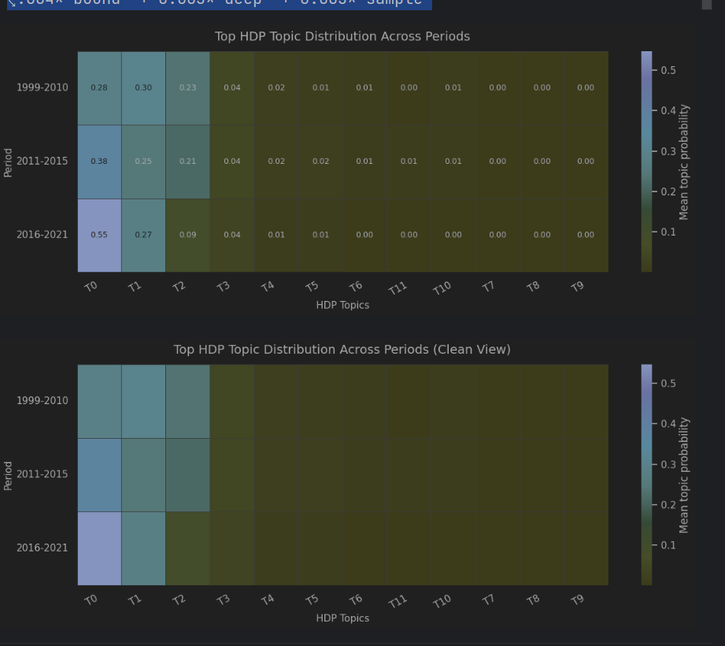
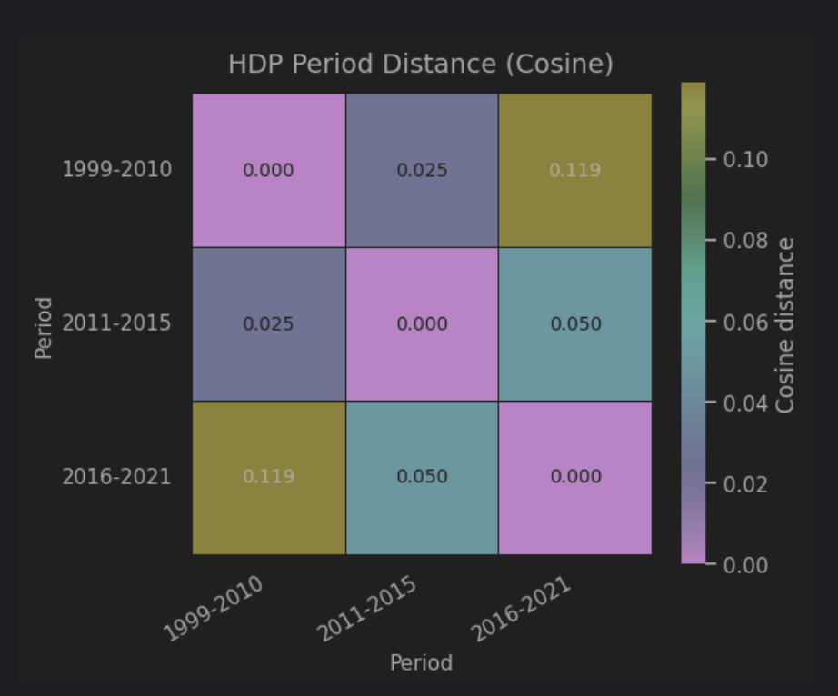
Experiment 2:
• Period-specific HDP
Model the three periods separately
Inspect the topics formed within each period
Then summarise the more important topics within each period
Use this to supplement the internal period structure that the global model cannot fully show

=== Sample topics for 1999-2010 ===

----- Topic 0 -----
0.012*randomized + 0.009*sample + 0.009*regression + 0.008*structured + 0.008*finding + 0.007*dependence + 0.007*basic + 0.007*provide + 0.007*assumed + 0.006*usual

----- Topic 1 -----
0.010*doe + 0.009*constant + 0.007*free + 0.007*require + 0.007*function + 0.007*logistic + 0.006*likely + 0.006*satisfies + 0.006*relation + 0.006*kind

----- Topic 2 -----
0.011*additive + 0.010*sequence + 0.010*efficient + 0.008*concept + 0.008*representation + 0.008*studied + 0.007*case + 0.007*classification + 0.007*maximum + 0.007*reduce

----- Topic 3 -----
0.009*asymptotically + 0.008*future + 0.008*latent + 0.007*address + 0.007*algorithmic + 0.006*group + 0.006*multi + 0.006*source + 0.006*formulation + 0.006*issue

----- Topic 4 -----
0.011*bregman + 0.009*increasing + 0.009*required + 0.008*solve + 0.008*access + 0.007*appropriate + 0.007*increase + 0.007*word + 0.006*arbitrary + 0.006*definition

----- Topic 5 -----
0.010*negative + 0.009*form + 0.008*various + 0.008*requires + 0.007*theory + 0.007*equal + 0.007*effective + 0.007*robustness + 0.007*gradient + 0.007*svms

----- Topic 6 -----
0.009*active + 0.008*experimental + 0.008*application + 0.007*observation + 0.007*variety + 0.007*partial + 0.006*free + 0.006*construction + 0.006*clustering + 0.006*significantly

----- Topic 7 -----
0.009*distributed + 0.009*requirement + 0.008*representation + 0.008*relationship + 0.007*likely + 0.007*adapted + 0.007*series + 0.007*processing + 0.006*algorithmic + 0.006*powerful

----- Topic 8 -----
0.012*rule + 0.010*power + 0.008*zero + 0.008*complex + 0.007*identify + 0.007*solve + 0.007*convexity + 0.007*semi + 0.007*popular + 0.007*action

----- Topic 9 -----
0.008*clustering + 0.008*quadratic + 0.008*furthermore + 0.008*noisy + 0.008*geometric + 0.007*confidence + 0.007*family + 0.007*kind + 0.006*decision + 0.006*possible

==============================
• Training HDP for period: 2011-2015
• Number of documents: 1028
==============================
• Vocabulary size: 2029
=== Sample topics for 2011-2015 ===

----- Topic 0 -----
0.014*study + 0.010*graph + 0.008*process + 0.008*structure + 0.008*observed + 0.007*domain + 0.007*flow + 0.007*discovery + 0.006*initial + 0.006*graphical

----- Topic 1 -----
0.008*kernel + 0.007*demand + 0.007*multiple + 0.006*technique + 0.005*multi + 0.004*predictive + 0.004*adopted + 0.004*particularly + 0.004*allow + 0.003*structure

----- Topic 2 -----
0.008*available + 0.007*graphical + 0.005*study + 0.005*temporal + 0.005*seek + 0.004*keywords + 0.004*indicates + 0.004*learn + 0.004*linear + 0.004*kernel

----- Topic 3 -----
0.011*area + 0.011*prediction + 0.007*error + 0.006*promising + 0.005*classifier + 0.005*connection + 0.005*allowed + 0.005*motivated + 0.004*classification + 0.004*machine

----- Topic 4 -----
0.015*inference + 0.006*space + 0.004*predictor + 0.004*predictive + 0.004*dynamical + 0.004*latent + 0.004*guarantee + 0.004*learned + 0.003*provably + 0.003*developed

----- Topic 5 -----
0.004*bound + 0.004*graph + 0.004*vector + 0.003*deep + 0.003*machine + 0.003*standard + 0.003*relate + 0.003*representing + 0.003*minimax + 0.003*symbolic

----- Topic 6 -----
0.003*correspondence + 0.003*general + 0.003*form + 0.003*having + 0.003*multiclass + 0.003*allow + 0.003*neighbour + 0.003*situation + 0.003*formula + 0.003*mean

----- Topic 7 -----
0.008*inference + 0.005*space + 0.004*function + 0.004*guarantee + 0.003*regret + 0.003*dynamical + 0.003*learned + 0.003*latent + 0.003*predictor + 0.003*principle

----- Topic 8 -----
0.004*prediction + 0.003*scenario + 0.003*direction + 0.003*class + 0.003*field + 0.003*exponential + 0.003*wind + 0.003*play + 0.003*reproducing + 0.002*rapidly

----- Topic 9 -----
0.006*gap + 0.006*interaction + 0.005*gain + 0.005*make + 0.005*kernel + 0.004*work + 0.004*discovery + 0.004*application + 0.004*connection + 0.003*evaluated

==============================
• Training HDP for period: 2016-2021
• Number of documents: 5743
==============================
=== Sample topics for 2016-2021 ===

----- Topic 0 -----
0.012*network + 0.007*training + 0.007*graph + 0.007*neural + 0.006*feature + 0.006*deep + 0.004*work + 0.004*machine + 0.004*prediction + 0.004*datasets

----- Topic 1 -----
0.008*network + 0.005*training + 0.005*neural + 0.004*deep + 0.004*feature + 0.004*work + 0.004*machine + 0.004*best + 0.004*prediction + 0.003*policy

----- Topic 2 -----
0.008*network + 0.006*training + 0.005*neural + 0.004*feature + 0.004*prediction + 0.004*deep + 0.004*work + 0.003*machine + 0.003*space + 0.003*accuracy

----- Topic 3 -----
0.005*network + 0.004*training + 0.003*neural + 0.003*feature + 0.003*machine + 0.003*user + 0.003*deep + 0.003*prediction + 0.003*best + 0.002*work

----- Topic 4 -----
0.004*network + 0.004*training + 0.003*feature + 0.003*machine + 0.003*neural + 0.002*prediction + 0.002*best + 0.002*deep + 0.002*linear + 0.002*agent

----- Topic 5 -----
0.004*network + 0.004*training + 0.003*deep + 0.003*graph + 0.003*neural + 0.002*datasets + 0.002*existing + 0.002*machine + 0.002*classifier + 0.002*norm

----- Topic 6 -----
0.003*bound + 0.002*regret + 0.002*adversarial + 0.002*network + 0.002*deep + 0.002*discriminator + 0.002*sample + 0.002*training + 0.001*distribution + 0.001*mathcal

----- Topic 7 -----
0.004*network + 0.002*multi + 0.002*neural + 0.002*prediction + 0.002*collected + 0.002*label + 0.002*classification + 0.001*deep + 0.001*feature + 0.001*teacher

----- Topic 8 -----
0.003*network + 0.002*neural + 0.002*training + 0.002*prediction + 0.002*large + 0.001*graph + 0.001*knn + 0.001*parameter + 0.001*uni + 0.001*scheme

----- Topic 9 -----
0.002*event + 0.002*level + 0.001*process + 0.001*feature + 0.001*categorize + 0.001*online + 0.001*approximating + 0.001*policy + 0.001*loss + 0.001*low

==============================
Top HDP topics in each period
==============================

========== 1999-2010 ==========

Topic 6 | mean weight = 0.0225
0.009*"active" + 0.008*"experimental" + 0.008*"application" + 0.007*"observation" + 0.007*"variety" + 0.007*"partial" + 0.006*"free" + 0.006*"construction" + 0.006*"clustering" + 0.006*"significantly"

Topic 2 | mean weight = 0.0220
0.011*"additive" + 0.010*"sequence" + 0.010*"efficient" + 0.008*"concept" + 0.008*"representation" + 0.008*"studied" + 0.007*"case" + 0.007*"classification" + 0.007*"maximum" + 0.007*"reduce"

Topic 17 | mean weight = 0.0181
0.009*"series" + 0.009*"labeled" + 0.008*"rank" + 0.007*"tree" + 0.007*"experimental" + 0.007*"structure" + 0.007*"markov" + 0.007*"observed" + 0.006*"human" + 0.006*"prediction"

Topic 117 | mean weight = 0.0170
0.011*"dimension" + 0.010*"point" + 0.010*"learn" + 0.009*"hold" + 0.009*"respect" + 0.008*"pattern" + 0.008*"select" + 0.007*"margin" + 0.007*"fisher" + 0.007*"prediction"

Topic 32 | mean weight = 0.0161
0.010*"behavior" + 0.009*"contribution" + 0.008*"improved" + 0.008*"mathematical" + 0.007*"converge" + 0.007*"estimation" + 0.007*"showing" + 0.007*"attribute" + 0.007*"convexity" + 0.007*"provides"

========== 2011-2015 ==========

Topic 2 | mean weight = 0.1148
0.008*"available" + 0.007*"graphical" + 0.005*"study" + 0.005*"temporal" + 0.005*"seek" + 0.004*"keywords" + 0.004*"indicates" + 0.004*"learn" + 0.004*"linear" + 0.004*"kernel"

Topic 0 | mean weight = 0.0817
0.014*"study" + 0.010*"graph" + 0.008*"process" + 0.008*"structure" + 0.008*"observed" + 0.007*"domain" + 0.007*"flow" + 0.007*"discovery" + 0.006*"initial" + 0.006*"graphical"

Topic 1 | mean weight = 0.0796
0.008*"kernel" + 0.007*"demand" + 0.007*"multiple" + 0.006*"technique" + 0.005*"multi" + 0.004*"predictive" + 0.004*"adopted" + 0.004*"particularly" + 0.004*"allow" + 0.003*"structure"

Topic 5 | mean weight = 0.0645
0.004*"bound" + 0.004*"graph" + 0.004*"vector" + 0.003*"deep" + 0.003*"machine" + 0.003*"standard" + 0.003*"relate" + 0.003*"representing" + 0.003*"minimax" + 0.003*"symbolic"

Topic 7 | mean weight = 0.0572
0.008*"inference" + 0.005*"space" + 0.004*"function" + 0.004*"guarantee" + 0.003*"regret" + 0.003*"dynamical" + 0.003*"learned" + 0.003*"latent" + 0.003*"predictor" + 0.003*"principle"

========== 2016-2021 ==========

Topic 0 | mean weight = 0.7610
0.012*"network" + 0.007*"training" + 0.007*"graph" + 0.007*"neural" + 0.006*"feature" + 0.006*"deep" + 0.004*"work" + 0.004*"machine" + 0.004*"prediction" + 0.004*"datasets"

Topic 1 | mean weight = 0.1205
0.008*"network" + 0.005*"training" + 0.005*"neural" + 0.004*"deep" + 0.004*"feature" + 0.004*"work" + 0.004*"machine" + 0.004*"best" + 0.004*"prediction" + 0.003*"policy"

Topic 2 | mean weight = 0.0375
0.008*"network" + 0.006*"training" + 0.005*"neural" + 0.004*"feature" + 0.004*"prediction" + 0.004*"deep" + 0.004*"work" + 0.003*"machine" + 0.003*"space" + 0.003*"accuracy"

Topic 3 | mean weight = 0.0179
0.005*"network" + 0.004*"training" + 0.003*"neural" + 0.003*"feature" + 0.003*"machine" + 0.003*"user" + 0.003*"deep" + 0.003*"prediction" + 0.003*"best" + 0.002*"work"

Topic 4 | mean weight = 0.0096
0.004*"network" + 0.004*"training" + 0.003*"feature" + 0.003*"machine" + 0.003*"neural" + 0.002*"prediction" + 0.002*"best" + 0.002*"deep" + 0.002*"linear" + 0.002*"agent"

=== Summary table ===
period rank topic_id mean_weight \
0 1999-2010 1 6 0.022458
1 1999-2010 2 2 0.022030
2 1999-2010 3 17 0.018086
3 1999-2010 4 117 0.017048
4 1999-2010 5 32 0.016114
5 2011-2015 1 2 0.114831
6 2011-2015 2 0 0.081659
7 2011-2015 3 1 0.079609
8 2011-2015 4 5 0.064545
9 2011-2015 5 7 0.057214
10 2016-2021 1 0 0.761027
11 2016-2021 2 1 0.120465
12 2016-2021 3 2 0.037466
13 2016-2021 4 3 0.017860
14 2016-2021 5 4 0.009647

topic_words
0 0.009*"active" + 0.008*"experimental" + 0.008*"application" + 0.007*"observation" + 0.007*"variety" + 0.007*"partial" + 0.006*"free" + 0.006*"construction" + 0.006*"clustering" + 0.006*"significantly"
1 0.011*"additive" + 0.010*"sequence" + 0.010*"efficient" + 0.008*"concept" + 0.008*"representation" + 0.008*"studied" + 0.007*"case" + 0.007*"classification" + 0.007*"maximum" + 0.007*"reduce"
2 0.009*"series" + 0.009*"labeled" + 0.008*"rank" + 0.007*"tree" + 0.007*"experimental" + 0.007*"structure" + 0.007*"markov" + 0.007*"observed" + 0.006*"human" + 0.006*"prediction"
3 0.011*"dimension" + 0.010*"point" + 0.010*"learn" + 0.009*"hold" + 0.009*"respect" + 0.008*"pattern" + 0.008*"select" + 0.007*"margin" + 0.007*"fisher" + 0.007*"prediction"
4 0.010*"behavior" + 0.009*"contribution" + 0.008*"improved" + 0.008*"mathematical" + 0.007*"converge" + 0.007*"estimation" + 0.007*"showing" + 0.007*"attribute" + 0.007*"convexity" + 0.007*"provides"
5 0.008*"available" + 0.007*"graphical" + 0.005*"study" + 0.005*"temporal" + 0.005*"seek" + 0.004*"keywords" + 0.004*"indicates" + 0.004*"learn" + 0.004*"linear" + 0.004*"kernel"
6 0.014*"study" + 0.010*"graph" + 0.008*"process" + 0.008*"structure" + 0.008*"observed" + 0.007*"domain" + 0.007*"flow" + 0.007*"discovery" + 0.006*"initial" + 0.006*"graphical"
7 0.008*"kernel" + 0.007*"demand" + 0.007*"multiple" + 0.006*"technique" + 0.005*"multi" + 0.004*"predictive" + 0.004*"adopted" + 0.004*"particularly" + 0.004*"allow" + 0.003*"structure"
8 0.004*"bound" + 0.004*"graph" + 0.004*"vector" + 0.003*"deep" + 0.003*"machine" + 0.003*"standard" + 0.003*"relate" + 0.003*"representing" + 0.003*"minimax" + 0.003*"symbolic"
9 0.008*"inference" + 0.005*"space" + 0.004*"function" + 0.004*"guarantee" + 0.003*"regret" + 0.003*"dynamical" + 0.003*"learned" + 0.003*"latent" + 0.003*"predictor" + 0.003*"principle"
10 0.012*"network" + 0.007*"training" + 0.007*"graph" + 0.007*"neural" + 0.006*"feature" + 0.006*"deep" + 0.004*"work" + 0.004*"machine" + 0.004*"prediction" + 0.004*"datasets"
11 0.008*"network" + 0.005*"training" + 0.005*"neural" + 0.004*"deep" + 0.004*"feature" + 0.004*"work" + 0.004*"machine" + 0.004*"best" + 0.004*"prediction" + 0.003*"policy"
12 0.008*"network" + 0.006*"training" + 0.005*"neural" + 0.004*"feature" + 0.004*"prediction" + 0.004*"deep" + 0.004*"work" + 0.003*"machine" + 0.003*"space" + 0.003*"accuracy"
13 0.005*"network" + 0.004*"training" + 0.003*"neural" + 0.003*"feature" + 0.003*"machine" + 0.003*"user" + 0.003*"deep" + 0.003*"prediction" + 0.003*"best" + 0.002*"work"
14 0.004*"network" + 0.004*"training" + 0.003*"feature" + 0.003*"machine" + 0.003*"neural" + 0.002*"prediction" + 0.002*"best" + 0.002*"deep" + 0.002*"linear" + 0.002*"agent"

HDP performs reasonably well as a supplementary topic model because it does not require the number of topics to be fixed in advance and still captures the broad temporal shift from earlier dispersed research themes to later concentration around network-, neural-, and graph-related topics. However, in this experiment its topics are often highly overlapping, especially in the global model, where many topics repeatedly contain similar terms such as network, training, neural, feature, and deep. In the period-specific setting, the later corpus becomes dominated by only a few closely related topics, suggesting strong concentration but limited topic separation. As a result, HDP is useful for validating broad trends, but it is less interpretable and less stable than the better LDA settings and BERTopic, so it is more suitable as a complementary comparison method than as the main explanatory model.

